Python

<https://www.appliedaicourse.com/course/11/Applied-Machine-learning-course>

<https://www.w3resource.com/python-exercises/>

### 

### Why Learn Python?

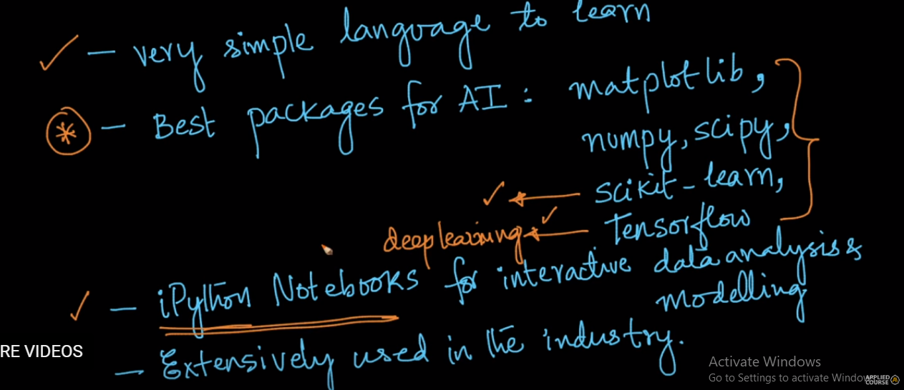

Matplotlib - Plotting library

Numpy, scipy - scientific computing

Scikit-learn - machine learning and general algorithms

Tensorflow- Deep learning

* Keyword
* Identifiers
* Comments
  + Single line comments
  + Multi line comments
* Indentation
* Statements
  + Single line statements
  + Multi line statements
* Variables
  + Variable Assignment
  + Multiple Assignment
* Storage Locations : id()

DataTypes

* Numbers
* Boolean
* Strings
* List
* Tuple
* Set
* Dictionary

Output/Input

* Promote input
* Format output

Operators

* Arthemetic. +, -, *, /, %, //, **
* Comparision >, <, ==, !=, >=, <=
* Logical and,or, not
* Bitwise &, |, ~, ^, >>, <<
* Assignment =, +=, -=, *=, /=, %=, //=, **=, &=, |=, ^=, >>=, <<=
* Identity is, is not
* Membership in, not in

Control Flow

* if...elif...else
* while
* for
* break and continue

Data Structures

* List
  + Creation - list of strings, list of integers, list of lists, list of heterogeneous datatypes
  + Length - len(list)
  + Append - append(list): add an item at the end of the list
  + Insert - insert(x, y): will add element y at location x
  + Remove - remove(x): will remove the first occurrence of x in the list
  + Append & Extend - list.append(lst2): will append the new list as a list [1, 2, [4, 5]]. list.extend(lst2) will extend the existing list [1, 2, 4, 5]
  + Delete - del list[1] will delete using the index and will not return anything, list.pop(1) will delete using the index and return the element from the list, list.remove(“first”) will delete an item using the item
  + Keywords - ‘in’ is used to test if an item in the list similarly ‘not in’
  + Reverse - list.reverse()
  + Sorting - sorted(numbers_list) will sort the list in ascending order and it will keep the Orginal list as ease. sorted(numbers_list, reverse=True) will sort in desc.list.sort() sort the list and sorted itself. list.sort() of different datatypes will throw an error
  + Multiple References - list = [1, 2, 3] abc.append(6) print(list) => [1,2,3,6]
  + String split to list - string.split() will return a list
  + Indexing - list[1] go in the forward direction. List[-1] in backward direction
  + Slicing - list [ start : end : stepsize ] lsit=[1, 2, 3, 4, 5] list[1:3] => [2,3]
  + Extend using + - same as extend
  + Count - list.count(item) give the frequency of item
  + Loopring - Simple for cna be used
  + Comprehension - provides a concise way to create list (find squares of range 10, Transpose as Matrix)
* Tuple
  + Creation - empty, list of integers, mixed datatype, nested tuple (list in tuple, tuple inside tuple)
  + Only Parantices is not enough, Parantencies is optional
  + Accessing elements in tuple
  + Slicing -
  + Changing elements
  + Concatenate tuples
  + Repetition of elements in tuple
  + Deleting - dev t
  + Count - find frequency of element t.count(1)
  + Index - fins the first time index of element t.index(3)
  + Membership - find if elements exist in tuple print( 5 in t)
  + Length - len(t)
  + Sort - take elements in tuple and then return a new sorted list (does not sort the tuple itself)
  + max(t)- find the maximum in tuple
  + min(t) - find the minimum element in tuple
  + sum(t) - find the sum of elements in tuple
* Sets
  + Ctreation -
  + Add single element
  + Add multiple elements using s.update()
  + Remove elements discard, remove, pop, clear
  + Set Operations union(|), intersection (&), difference(-), symmentric_difference(^), issubset
  + Frozen Sets - Immutable Sets
* Dictionary
  + Empty , integer keys, mixed keys
  + Access elements get, ‘’[]
  + Add Elements
  + Delete - pop, popItem, del, clear
  + Copy
  + items
  + Keys
  + Values
  + dir
* Strings
  + Creation single quotes, double quotes, triple quotes
  + Access characters in String
  + Change or Delete
  + Delete entire string
  + Concatenate or Repeat
  + Iterate through strings
  + Membership Tests
  + String Methods : lower, upper, split, join, find, replace

Functions

* Syntax
* Doc String
* Return Statement
* Example
* Types of Functions built-In Functions, User Defined Functions
* Built-in :
  + abs()
  + all()
  + dir()
  + divmod()
  + enumerate()
  + filter()
  + isinstance()
  + map()
  + reduce()
* User Defined functions
  + Definition
  + Example
  + Program to implement a calculator add, substract, divide, multiply

Function Arguments

* Default Arguments
* Keyword Arguments
* Arbitary Arguments

Recursion

* Program to implement Factorial of a number
* Advantages & Disadvantages
* Program to implement fibonacci sequence

Lambda

* Definition
* Simple examples

Modules

* Definition
* Import
  + Basic import
  + Import with renaming
  + Import specific function
  + Import all names
  + dir()

Packages

* Definition
* Import a module from package

Files

* File I/O
* Opening a File
* File Modes
* Closing a File
* Write to File
* Reading a File
  + read()
  + tell()
  + seek()
  + readline()
  + readlines()
* Renaming and Deleting
  + rename()
  + remove()
* Directory and File Management
  + getcwd()
  + listdir()
  + mkdir()
  + rmdir()
  + rmtree()

Exception Handling

* Definition
* Build-in-Exception : dir(__builltins__)
* Try, Except and Finally
* Catching Exception
* Catching Specific Exceptions
* Raisisng Exception : raise
* Try … finally

Debugging

* Debugger in python : pdb
* Trace : pdb.set_trace
* Commands : c, q, h, list, p, p locals(), p globals()

NumPy

* Introduction
* Simple Array
* Why is it useful
* Create Array
  + 1-D Array
  + 2-D Array : sharp -tuple, lenght
  + 3-D Array
  + Terms
  + arrange()
  + linspace()
  + ones()
  + zeros()
  + eye()
  + diag()
  + random.rand()
  + random.randn()
  + dtype()
  + Default datatype for zeros and ones
  + Other Datatype
* Indexing and Slicing
  + Indexing
  + Slicing
* Copies and Views
  + How Memory Efficency is Implemented
  + Shared Memory Issue
  + Work around for it
* Fancy Indexing
* ElementWise Operations
  + Scalar Addition
  + Arithmetic Operation
  + Vector Multiplication
  + Comparison
  + Logical Operation
  + Transcendental
  + Shape Mismatch
  + Basic Reductions
    - Computing sum
  + Other Reductions
  + Logical Operations
* Broadcasting
* Array Manipulations
  + Flattening
  + Reshaping

Matplotlib

* What is pyplot ?
* Simple Plot
* Grid and Plot Properties
* Controlling line properties
* Multiple plots

Pandas ( <http://pandas.pydata.org/pandas-docs/stable/> , <https://github.com/pandas-dev/pandas/blob/master/doc/cheatsheet/Pandas_Cheat_Sheet.pdf>`)

* Creating dataframe
* Using list tuples
* DataFrame Function
  + Shape
  + head()
  + tail()
  + slicing()
  + select single column
  + Select multiple column
  + describe()
* Key Operations
  + Load CSV FIle
  + Load Excel
  + Write Data to CSV ot XLS
  + Concatenate Data Frames
  + Join Data Frames
  + Numerical Indexing

Computational Complexity

* Space and Time Complexity

# CONTENT

### Keyword

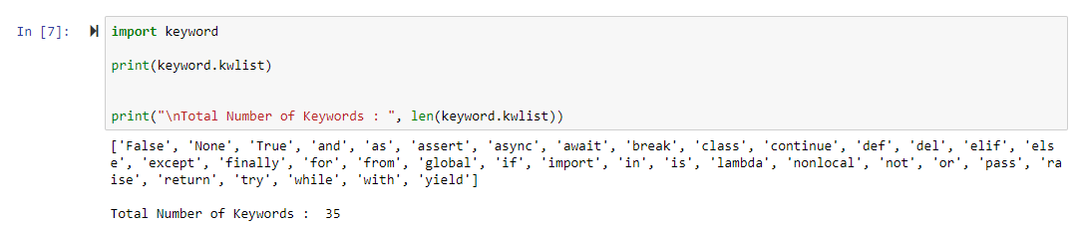

### Identifiers

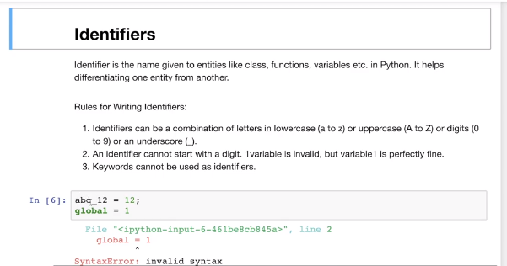

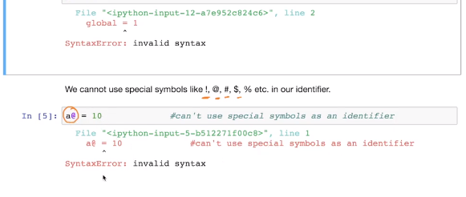

### Comments

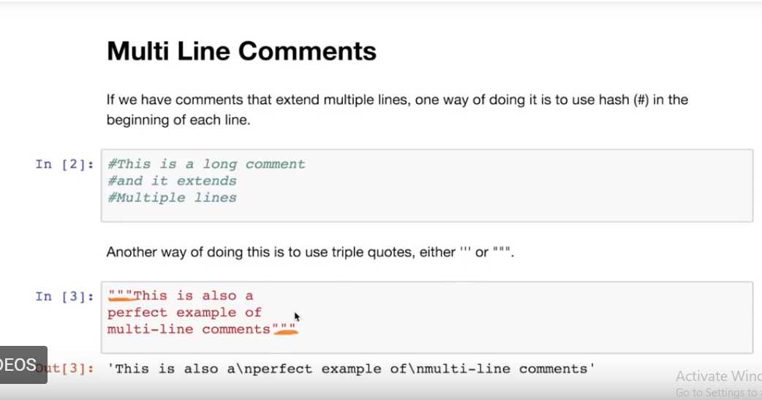

### Indentation

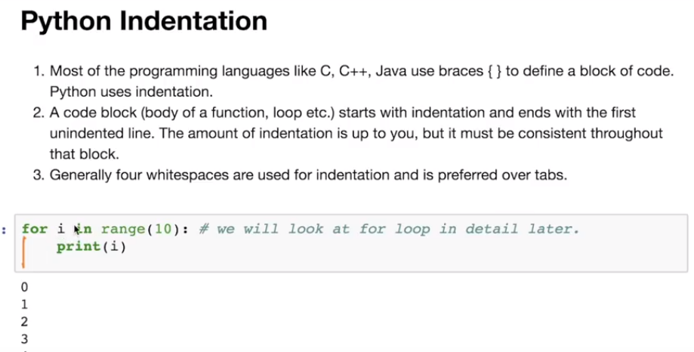

### Statements

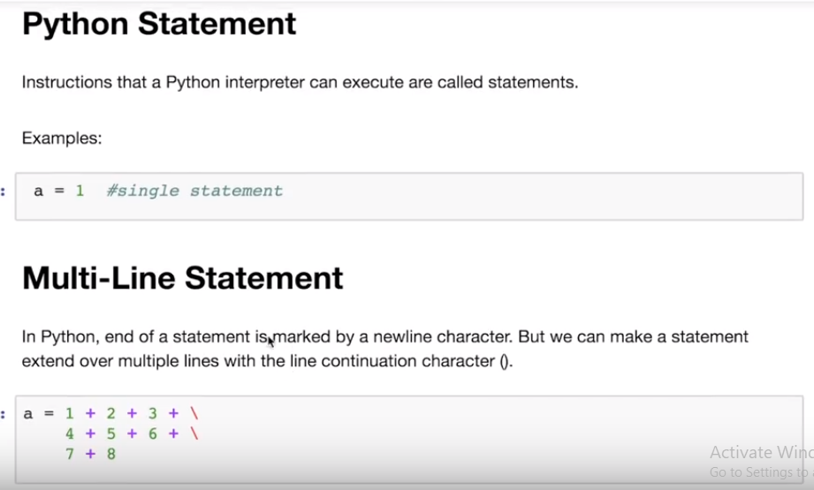

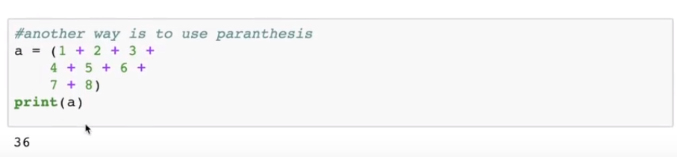

### Variables

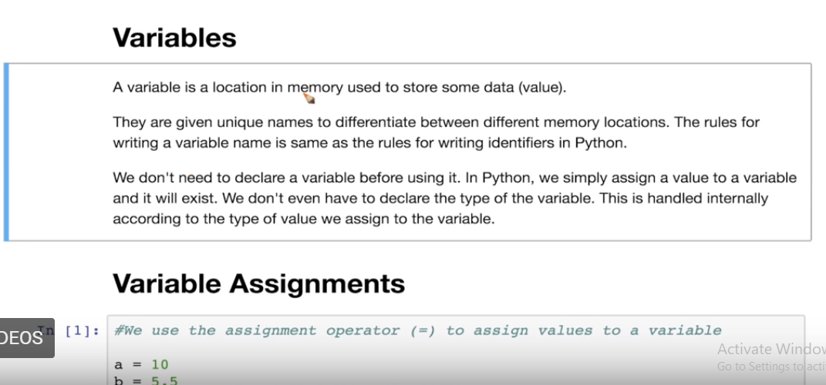

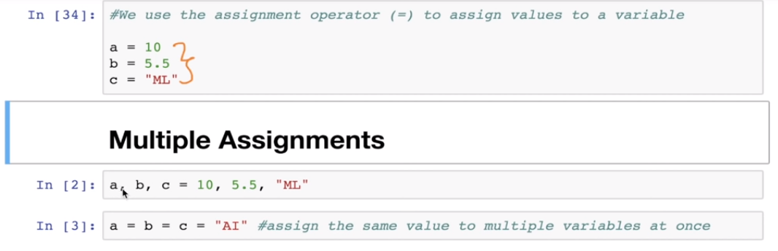

### Storage Location

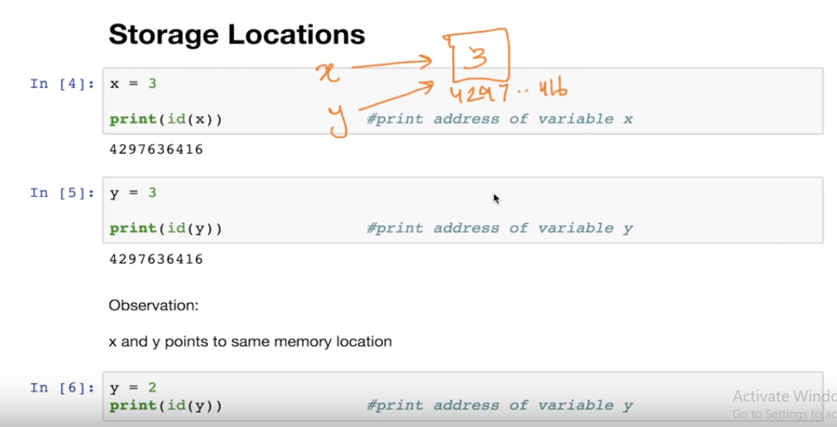

### Data Types

Everything in python has a datatype.

Everything in python is an object.

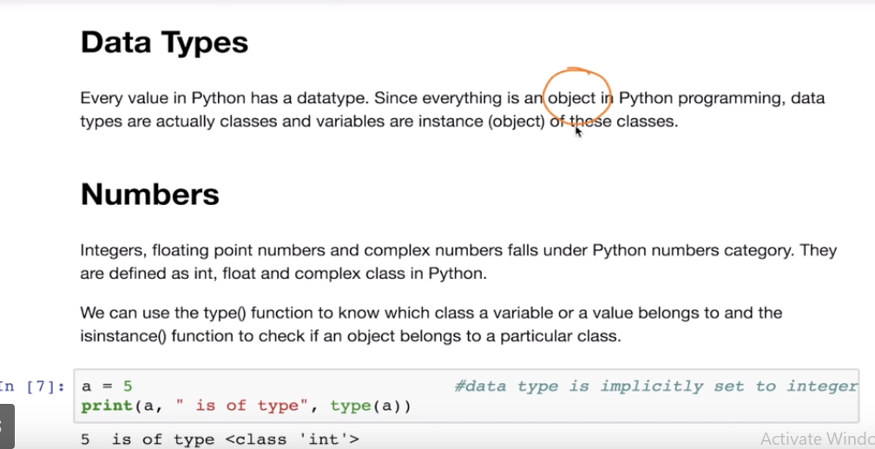

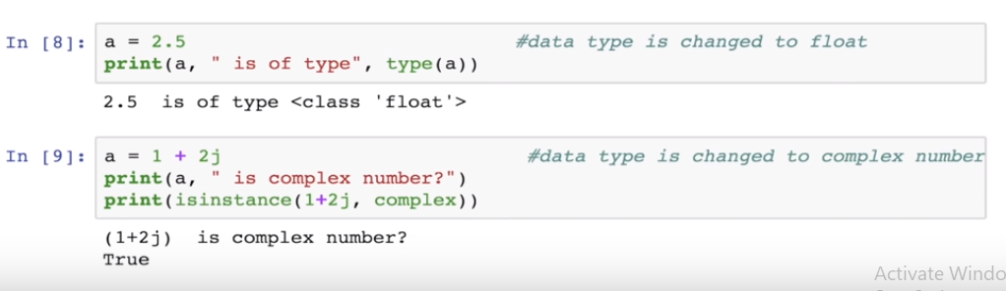

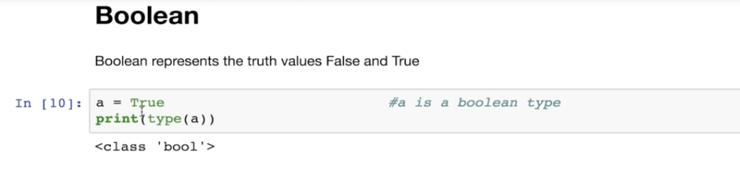

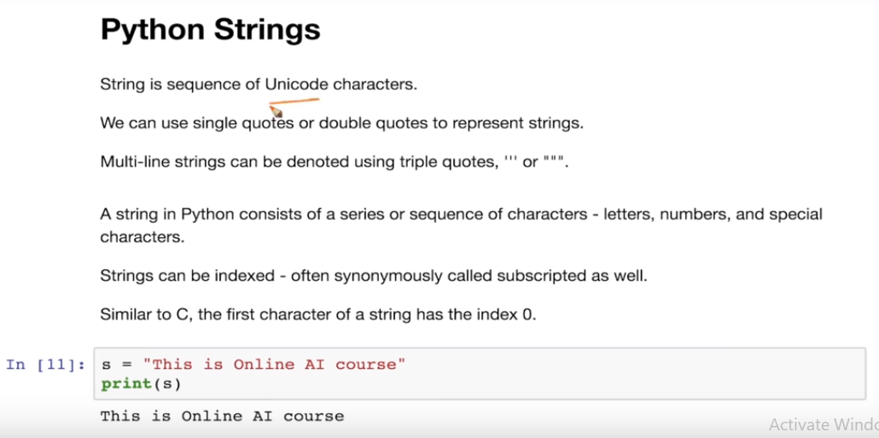

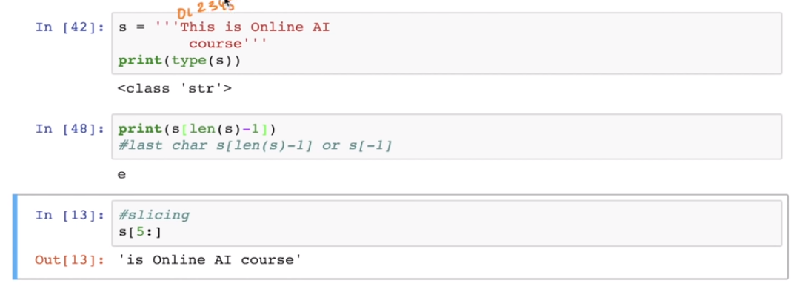

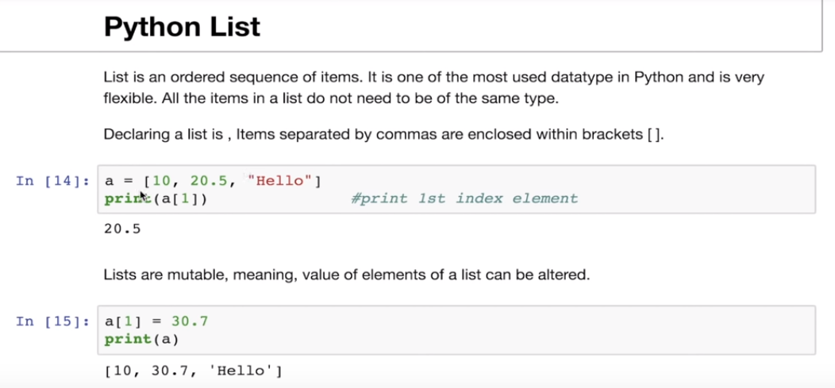

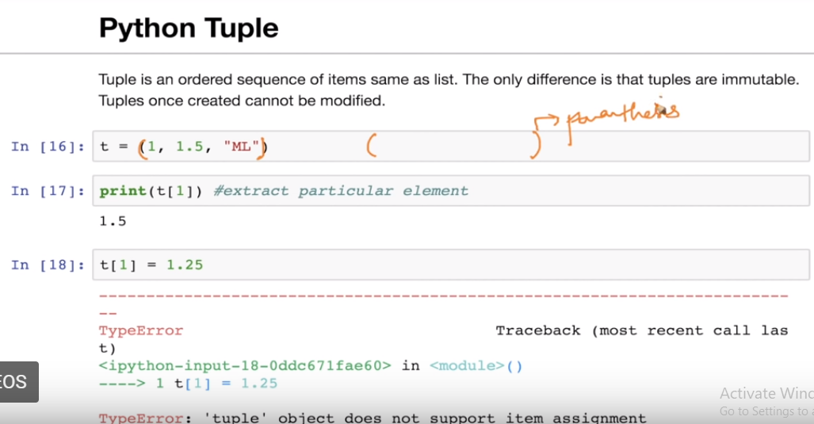

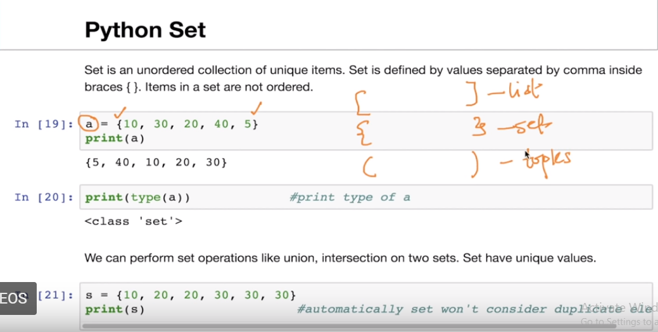

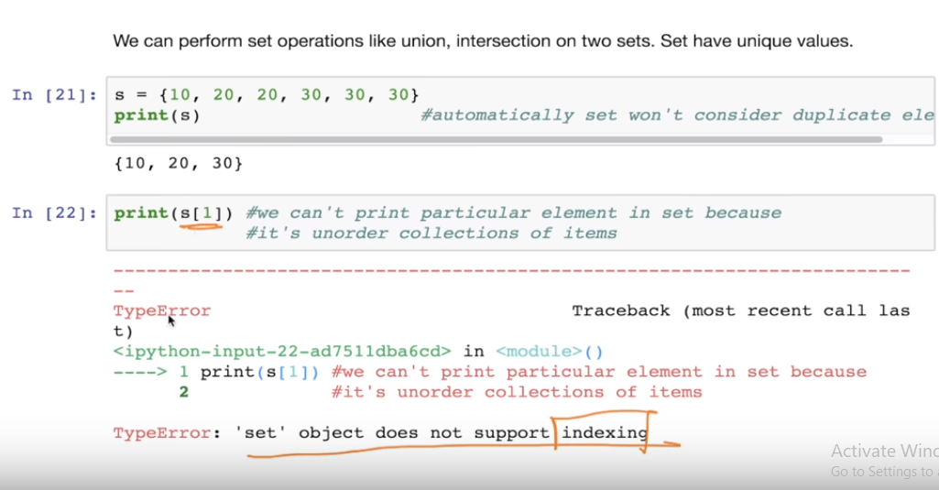

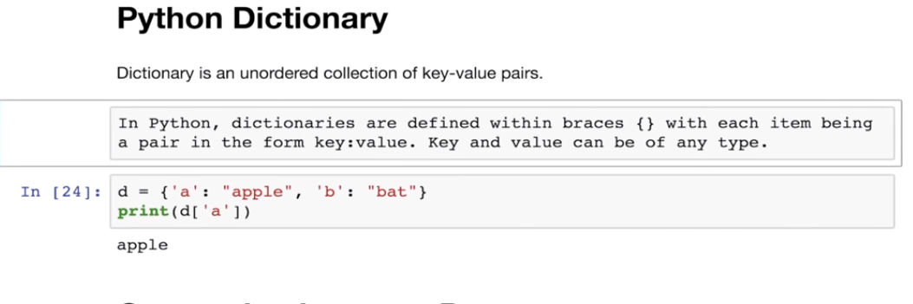

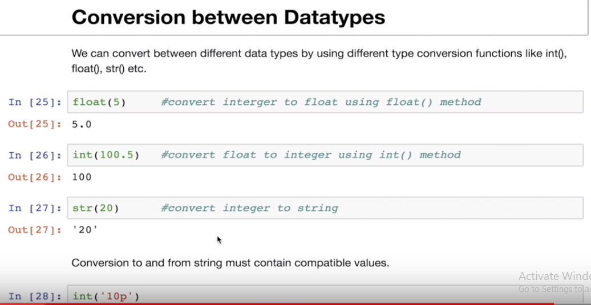

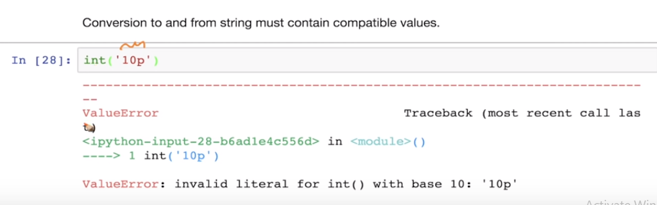

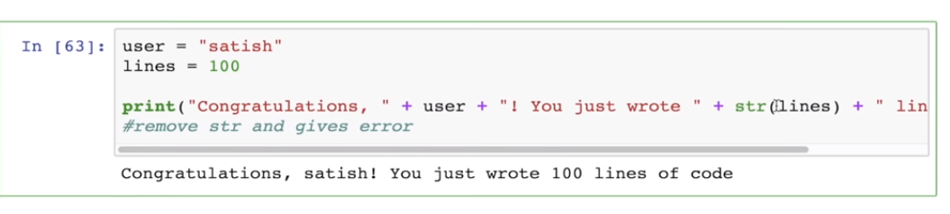

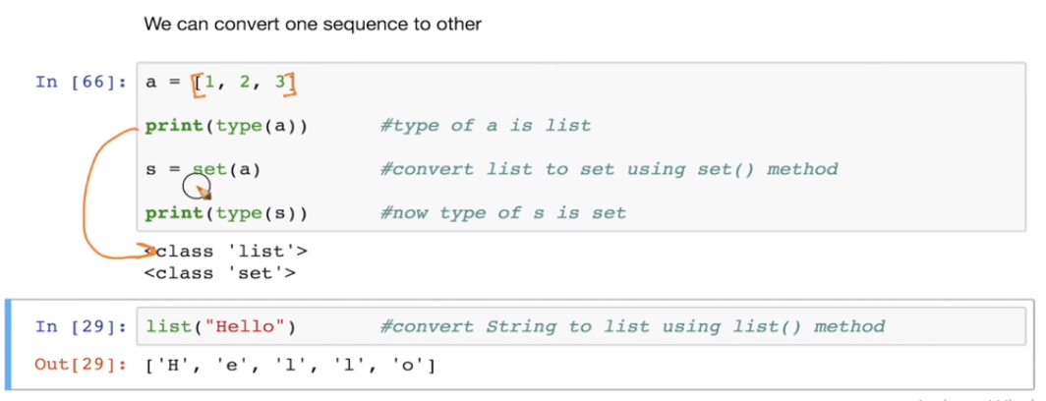

### Input/Output

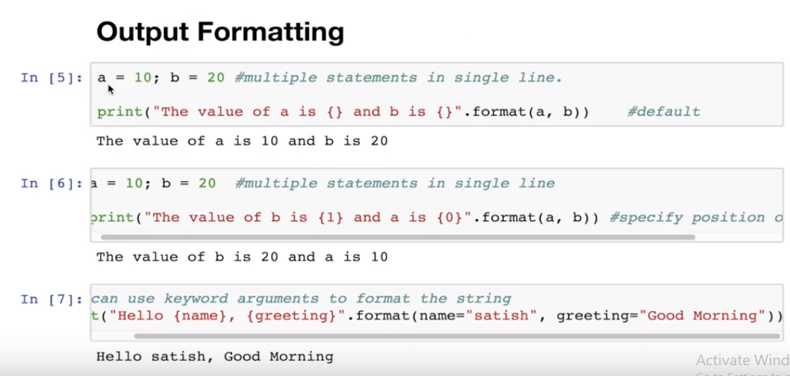

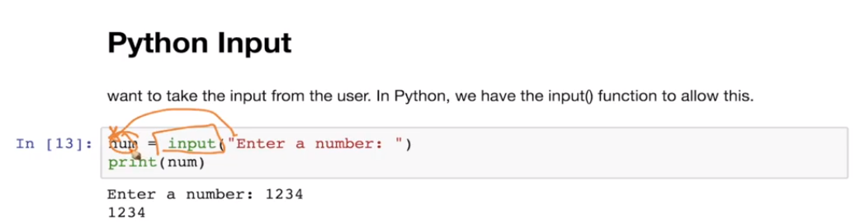

### Operators

Arthemetic

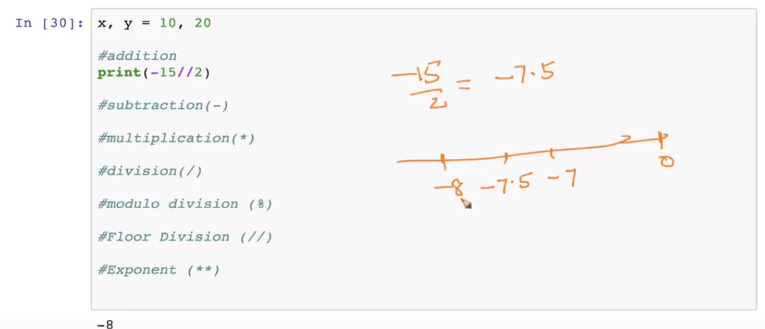

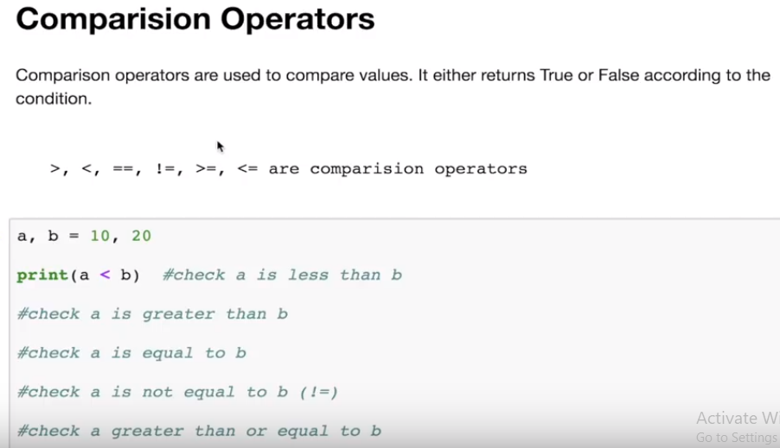

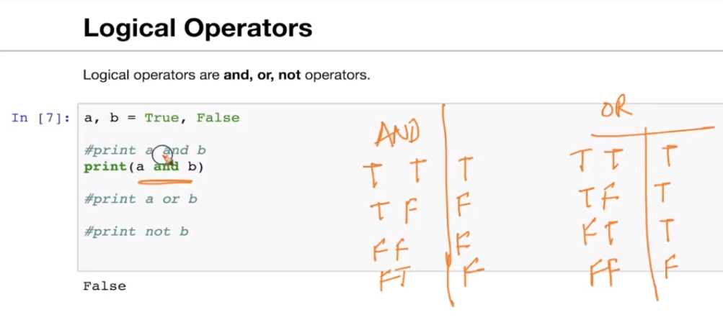

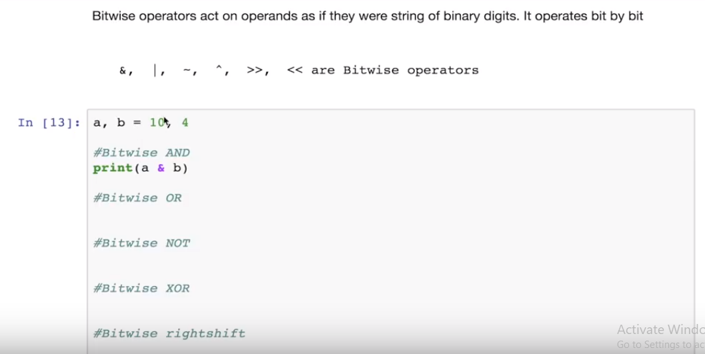

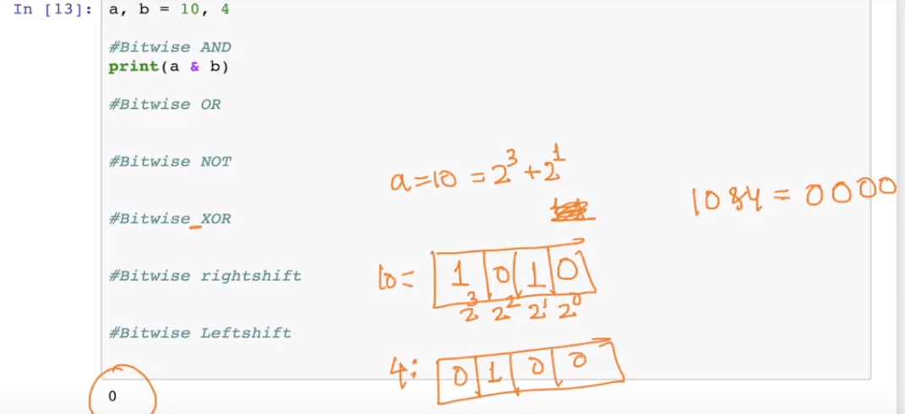

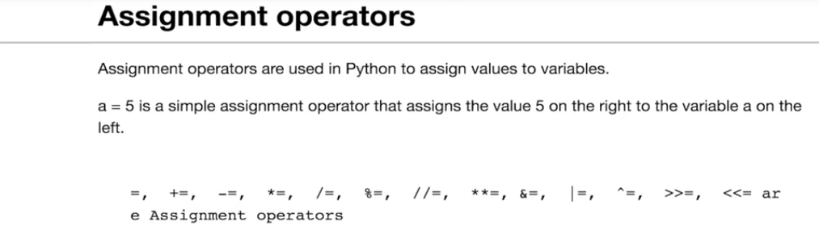

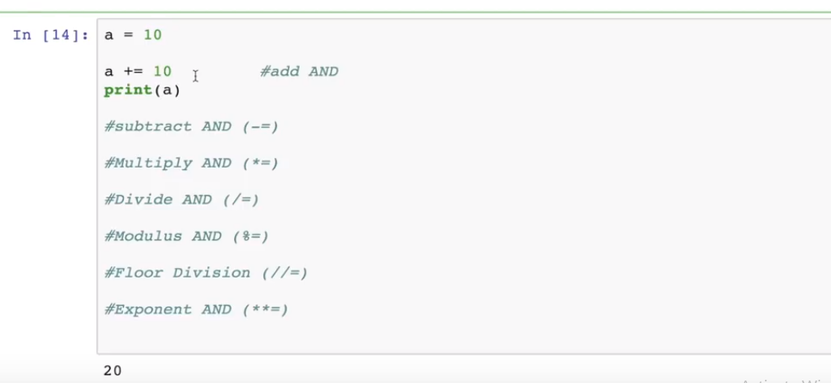

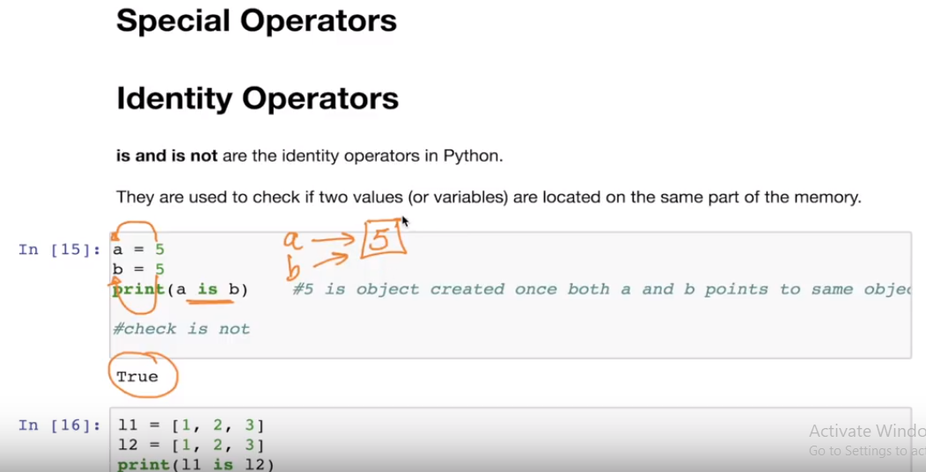

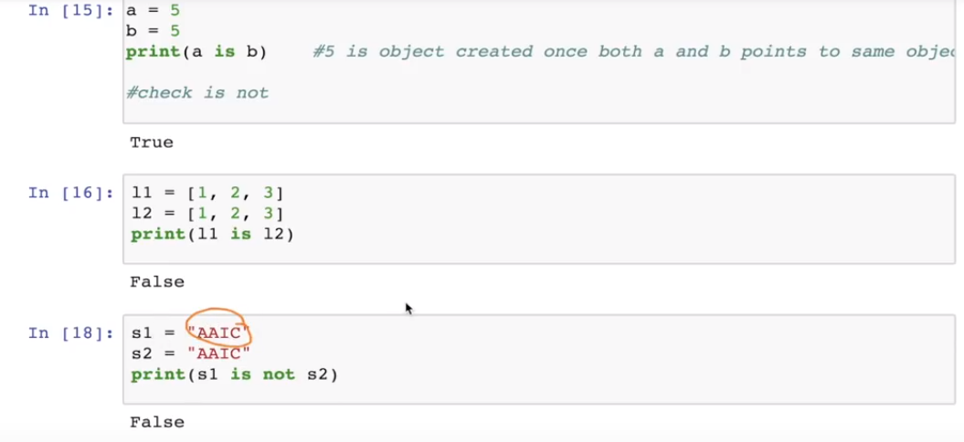

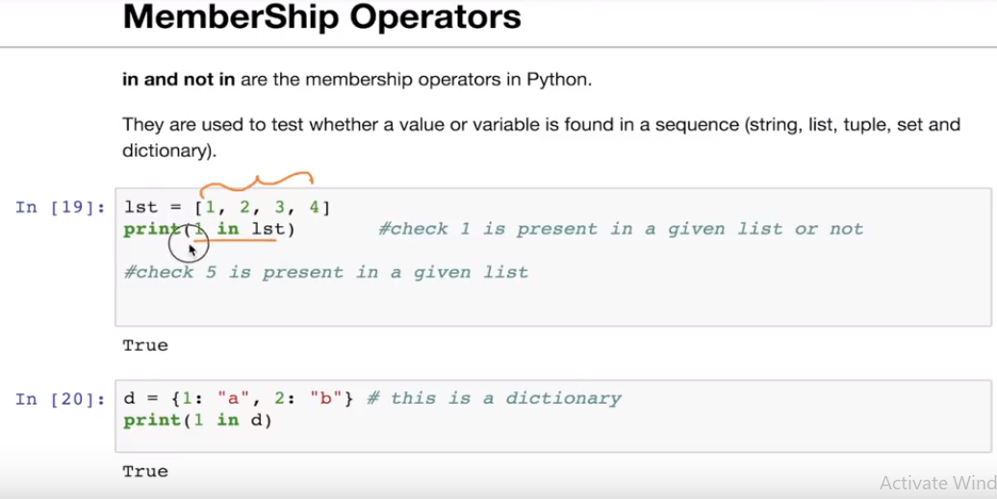

### Control Flow:

if...elif...else

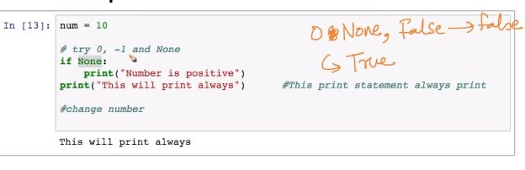

while

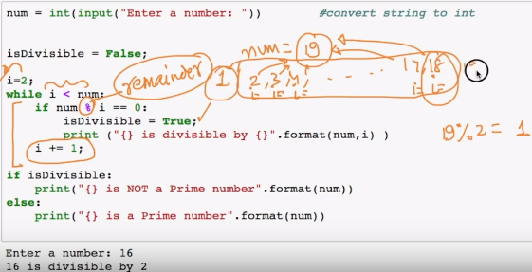

For

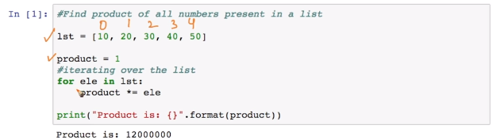

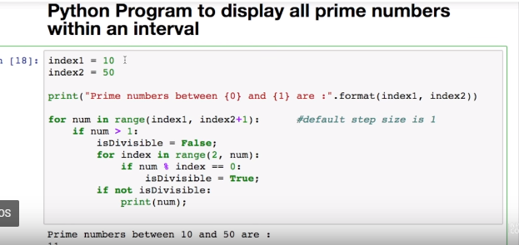

Break and continue

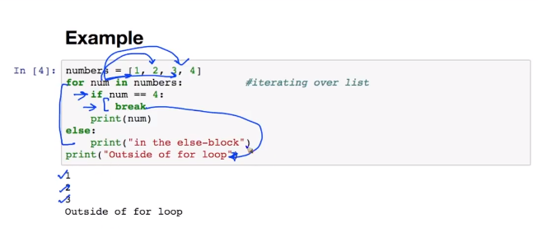

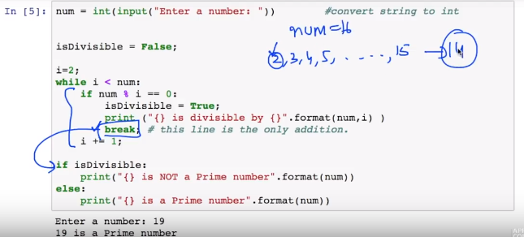

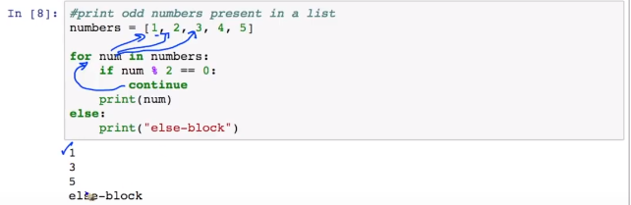

### List in-depth

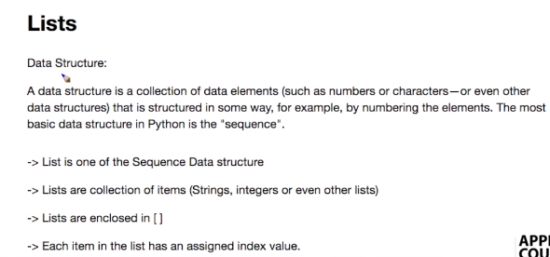

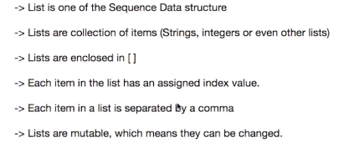

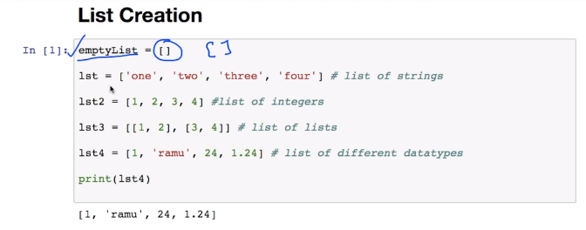

### List Comprehension

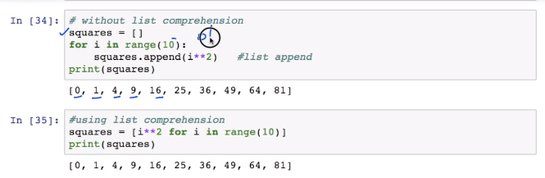

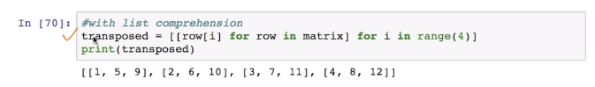

### Tuple

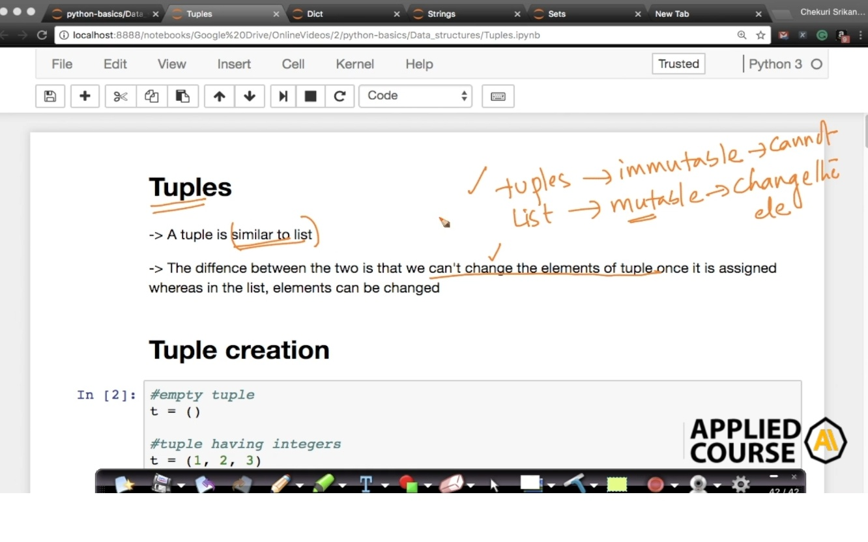

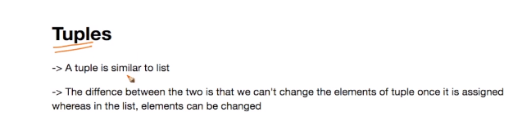

Parantices

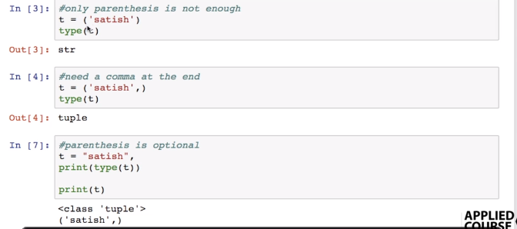

### Accessing Elements in tuple

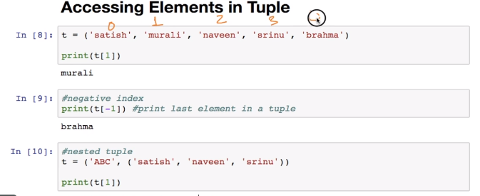

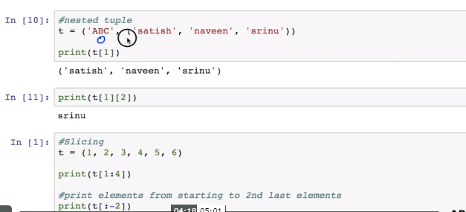

### Slicing

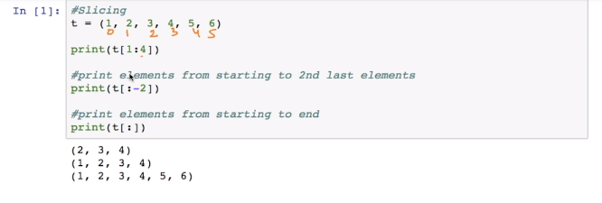

### Changing elements in tuple

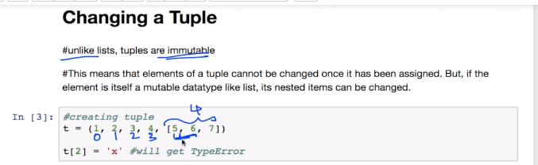

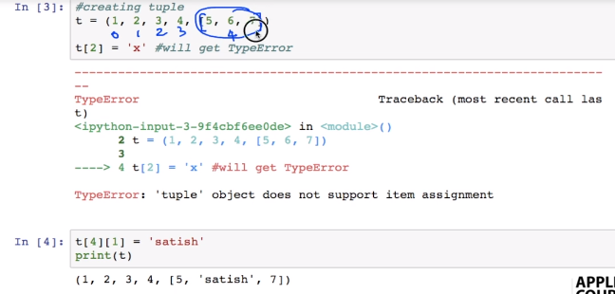

### Deleting a tuple

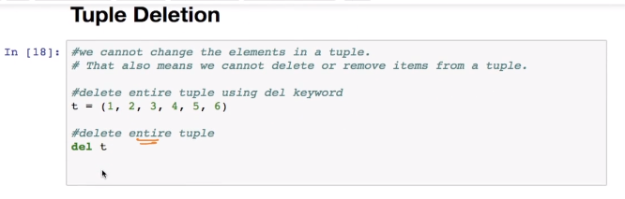

### Frequency of Element : count

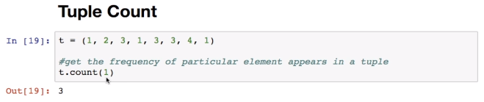

### Index

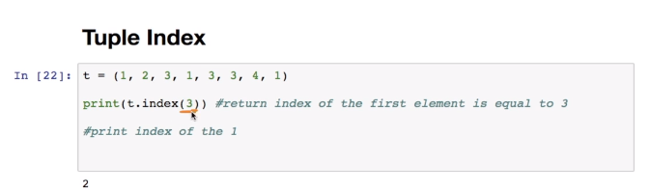

Membership

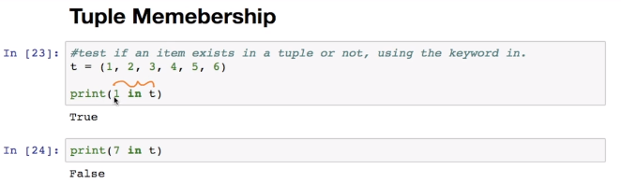

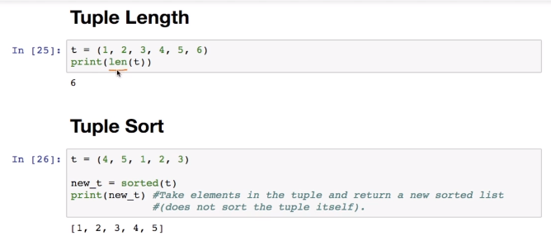

### Sets

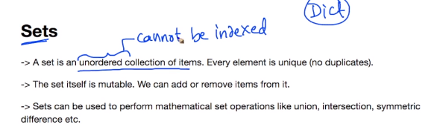

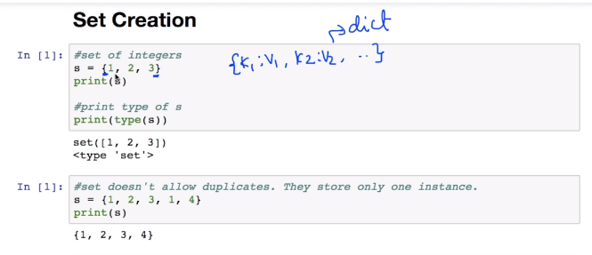

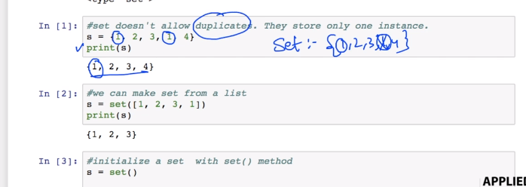

### Adding Elements in Set

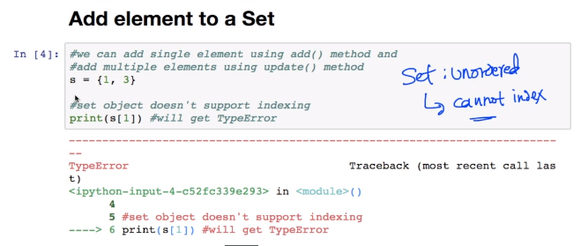

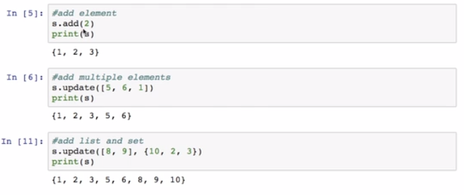

### Remove Elements

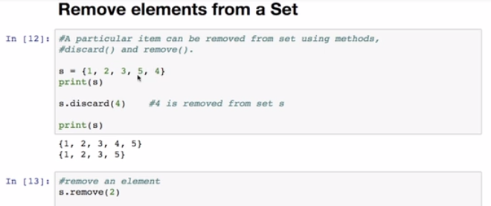

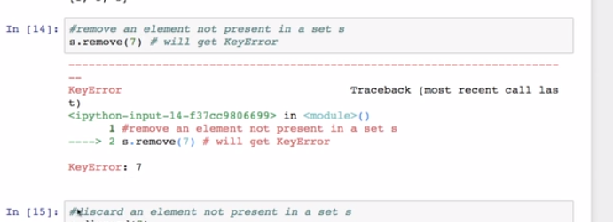

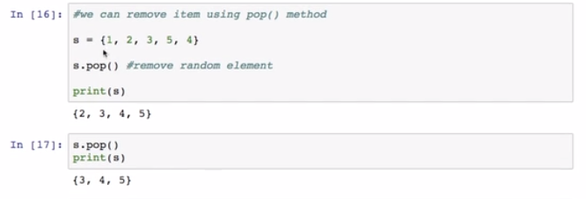

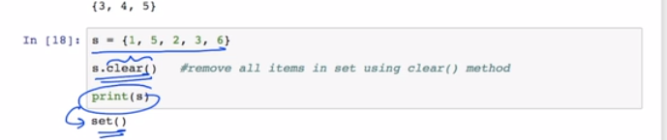

### Set Operation

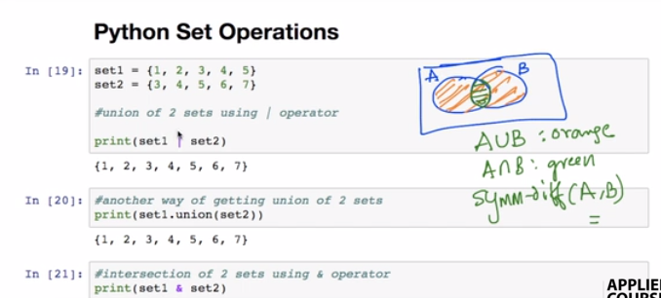

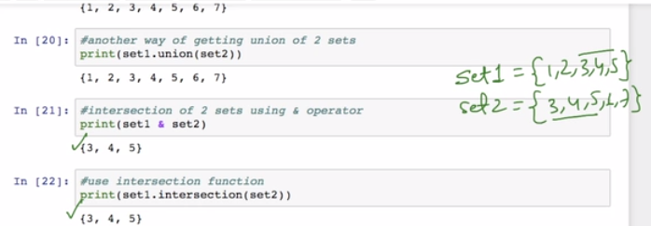

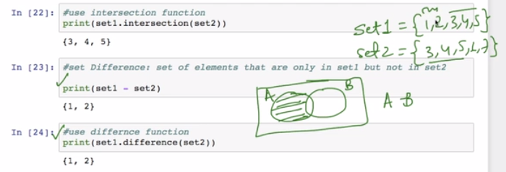

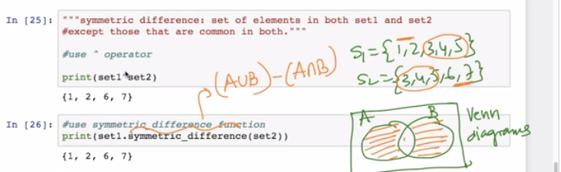

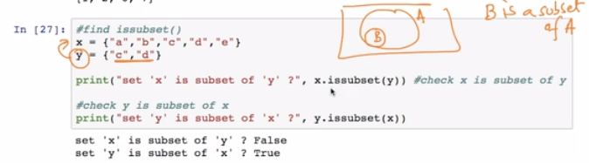

### Frozen Sets

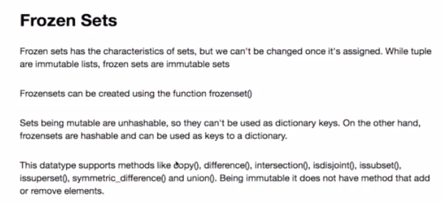

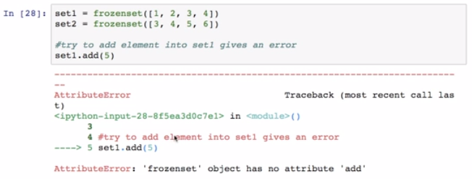

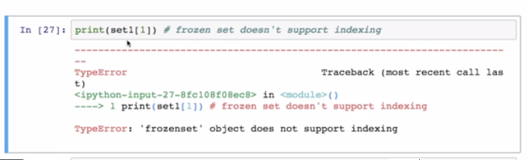

### Dictionary

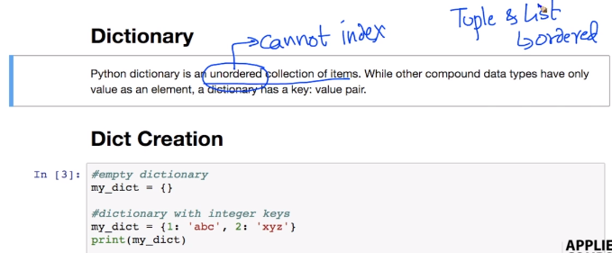

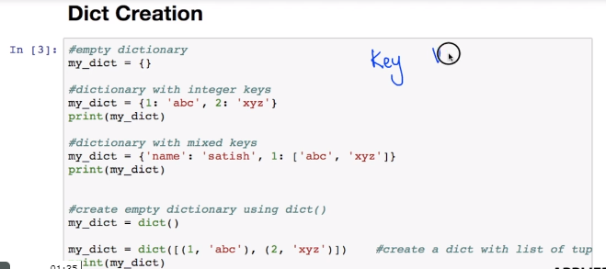

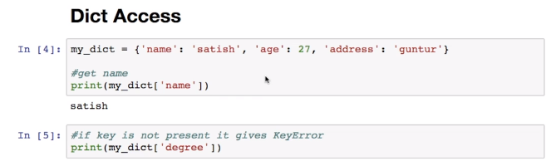

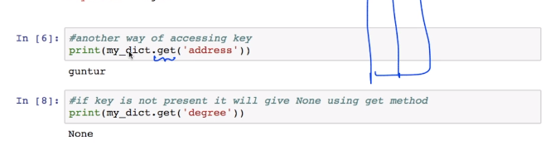

### Add Elements

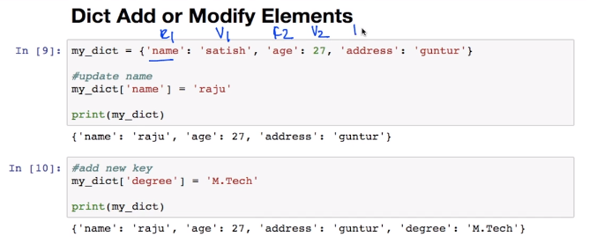

### Delete Elements

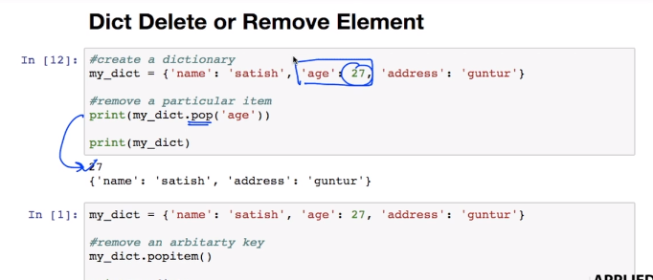

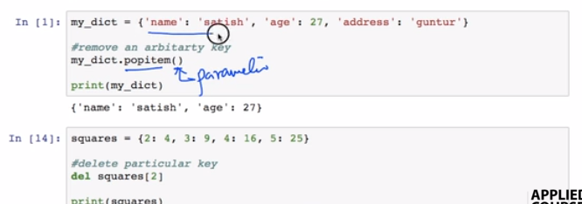

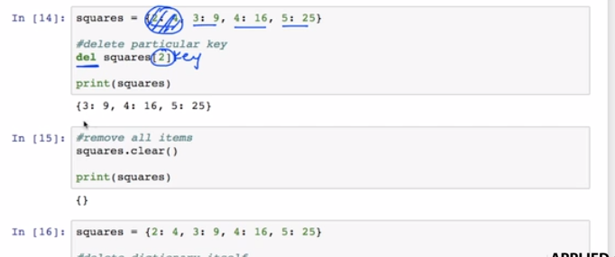

### Copy

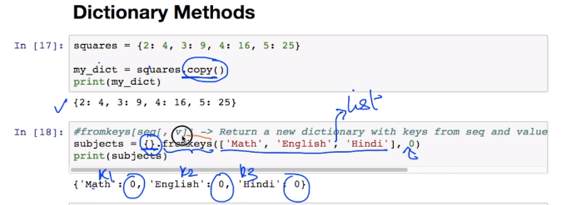

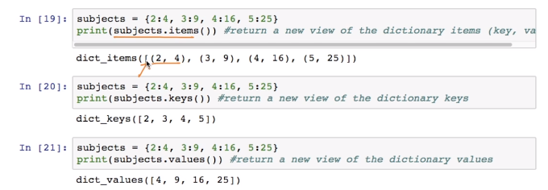

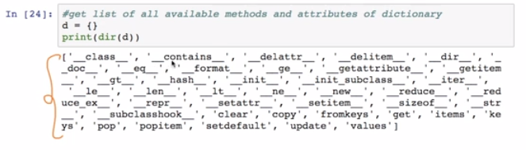

### Dist Comprehension

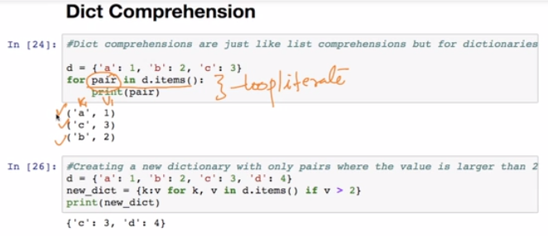

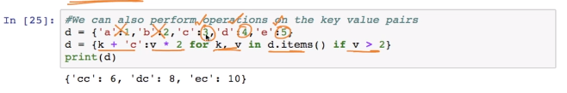

### Strings

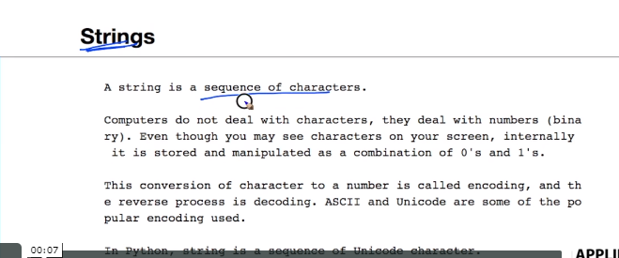

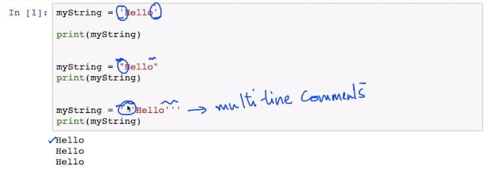

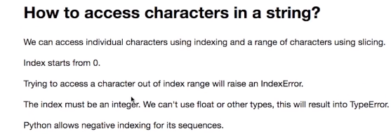

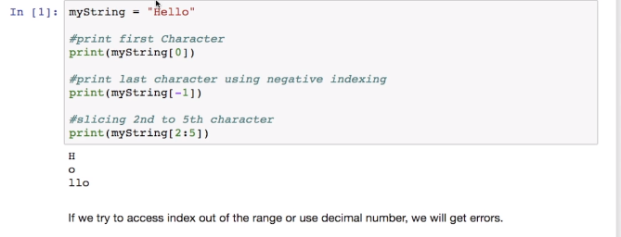

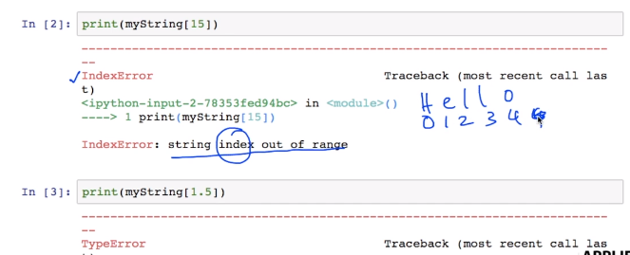

### Change or Delete

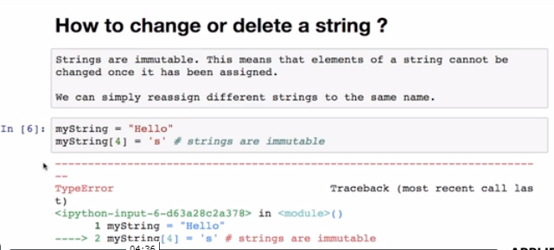

### Concatenation or Repeat

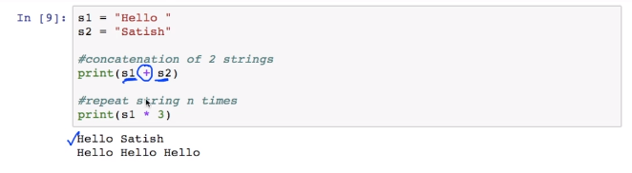

### Iterating Through String

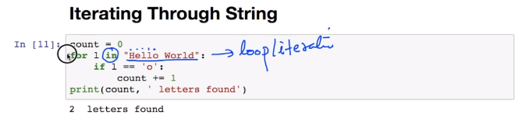

### Membership Test

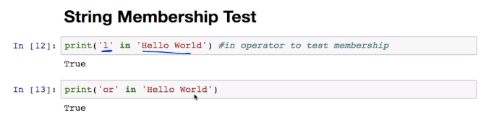

String Methods

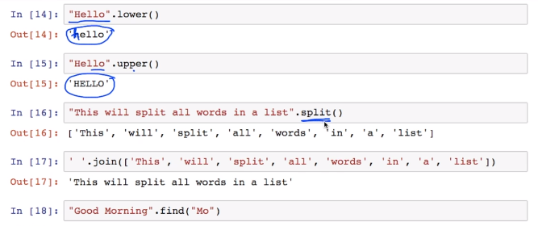

### Check if Palindrome

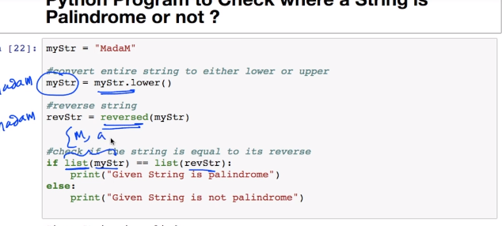

Sort words in Alphabetic Order

### FUNCTIONS

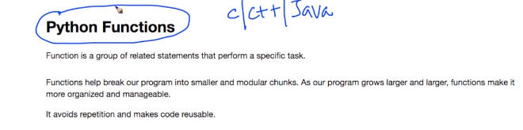

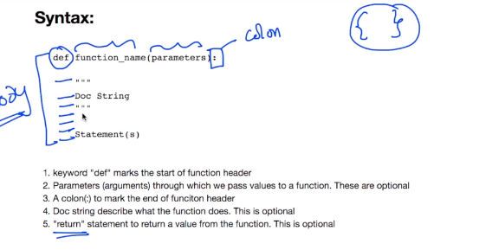

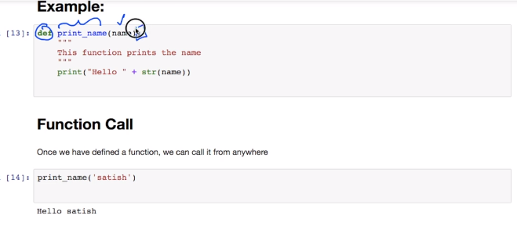

### Doc String

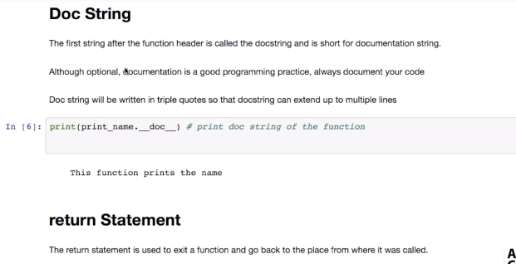

### Return Statement

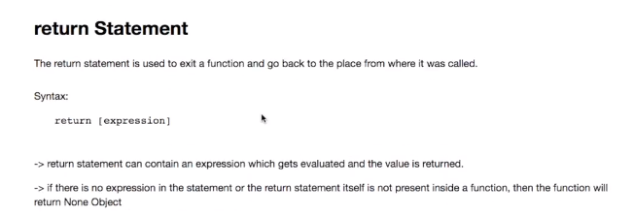

### Scope and Lifetime

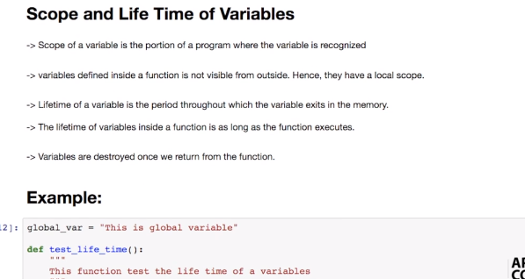

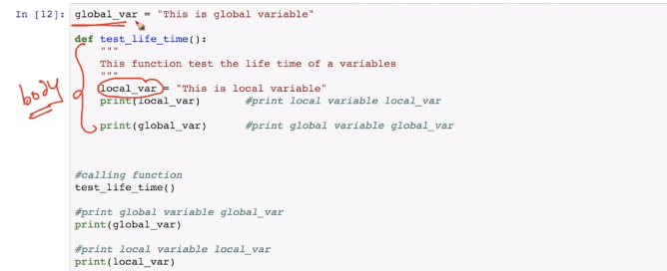

### Example HCF

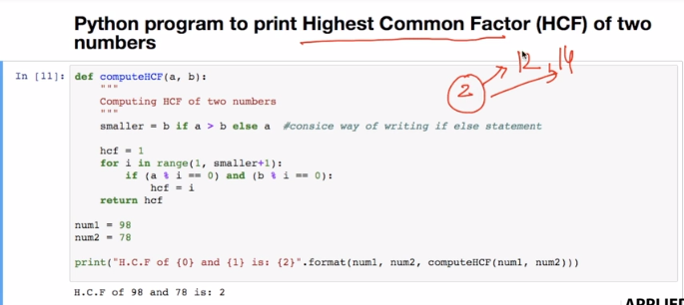

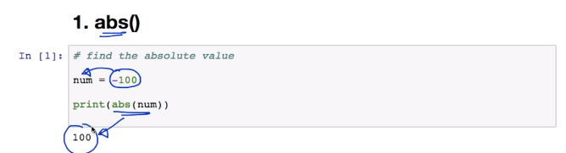

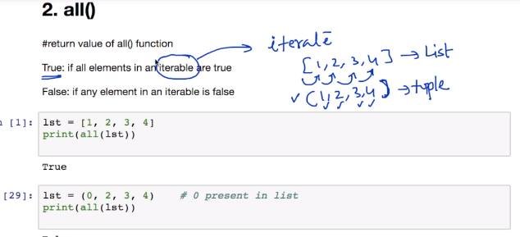

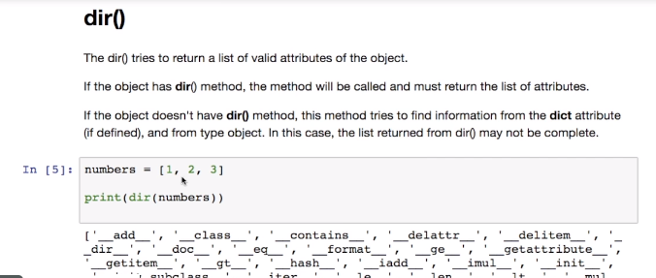

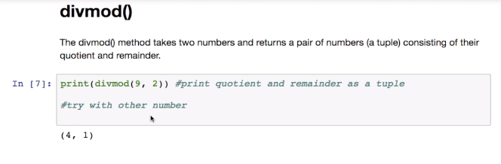

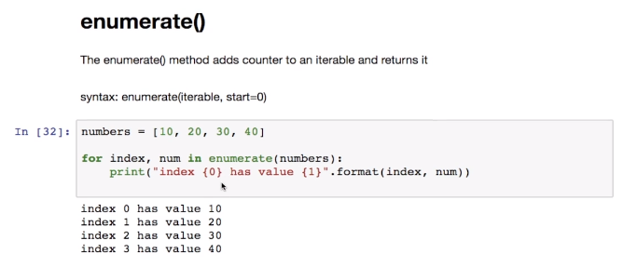

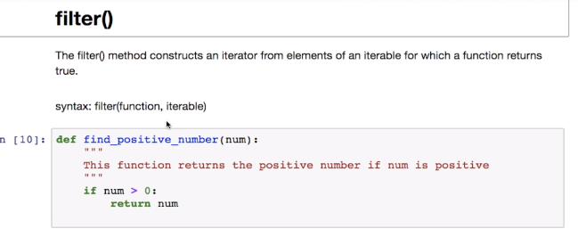

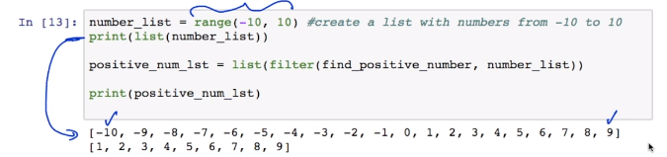

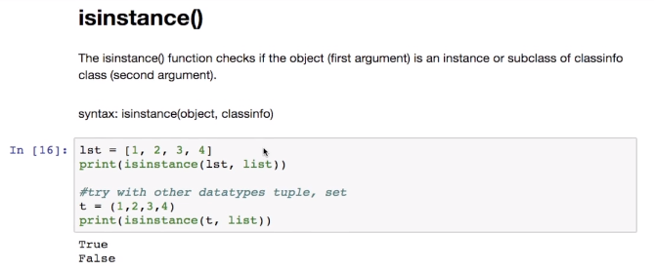

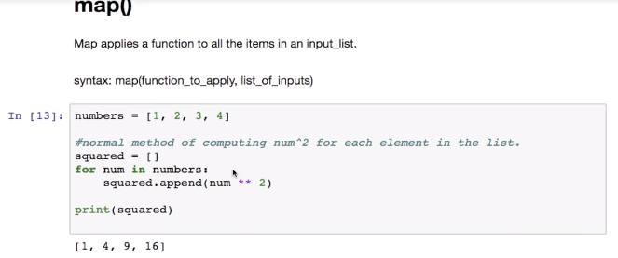

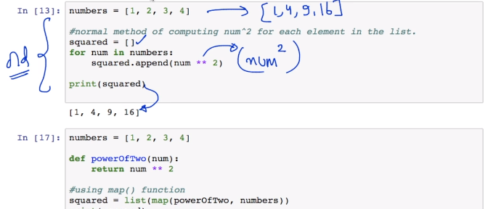

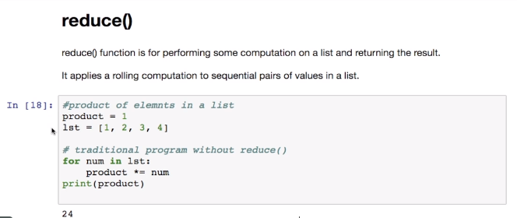

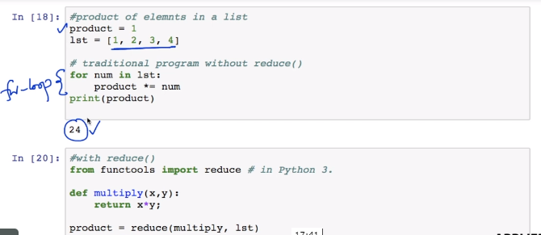

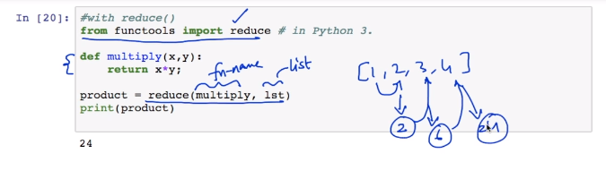

### User Defined Functions

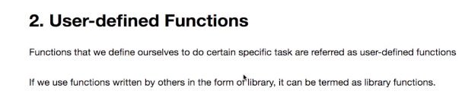

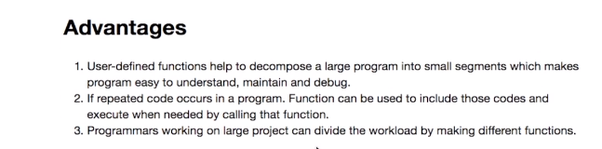

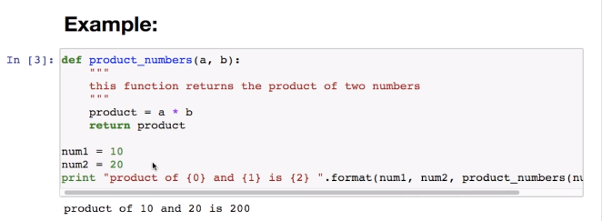

### Function Arguments

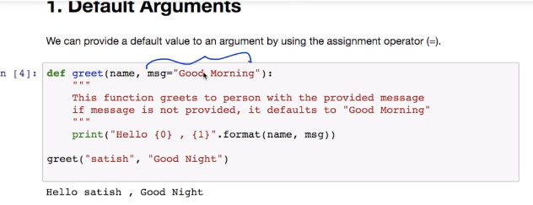

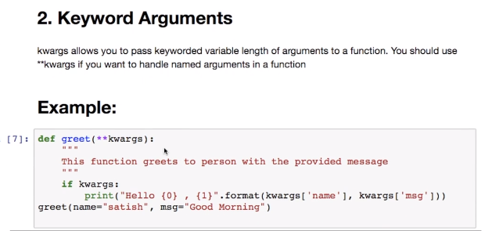

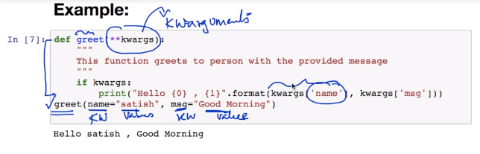

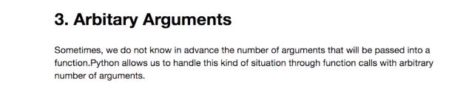

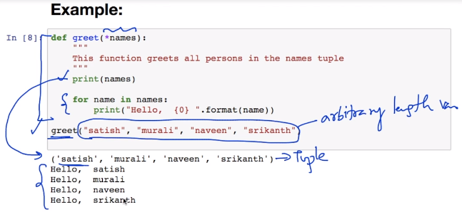

### Recursion

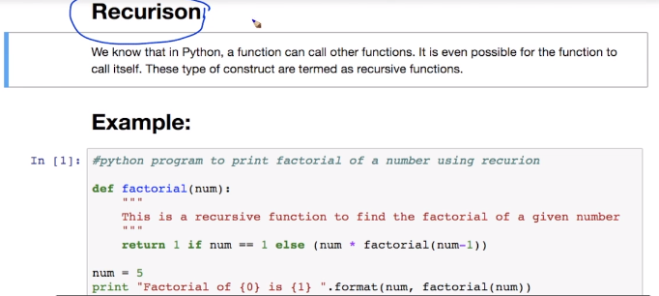

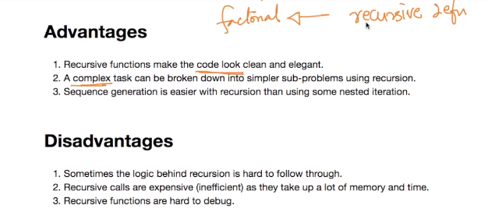

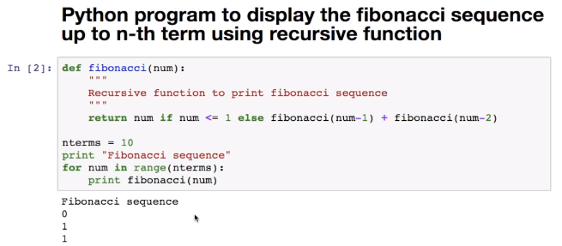

### Lambda

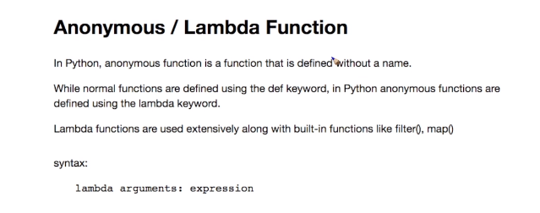

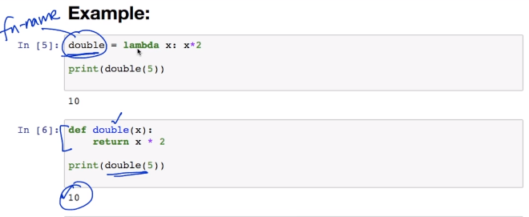

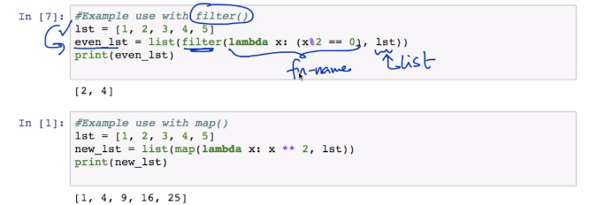

### Modules

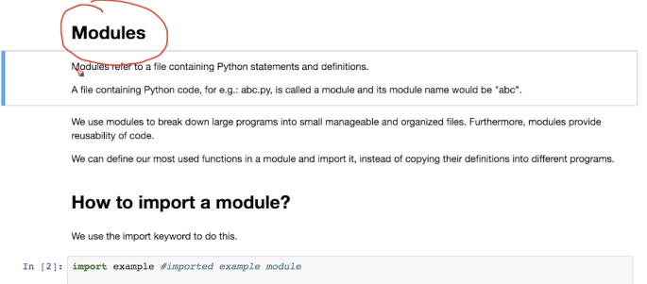

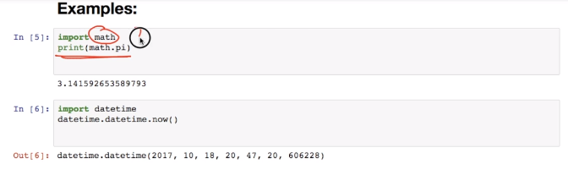

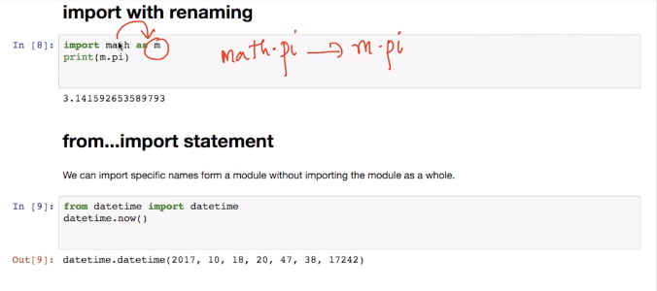

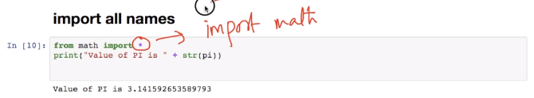

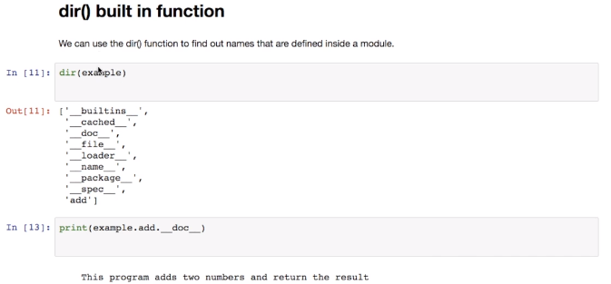

### Packages

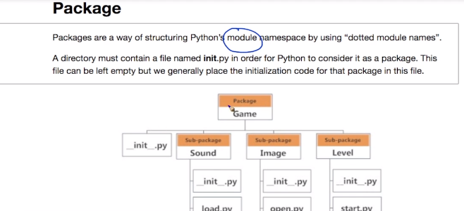

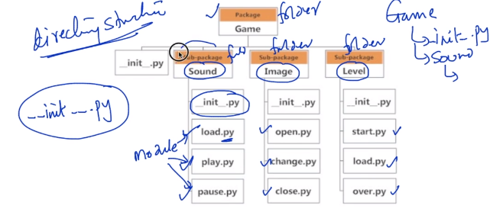

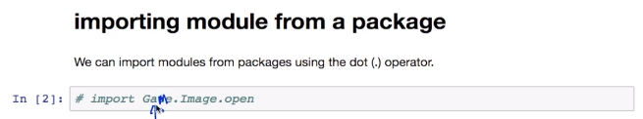

### Files

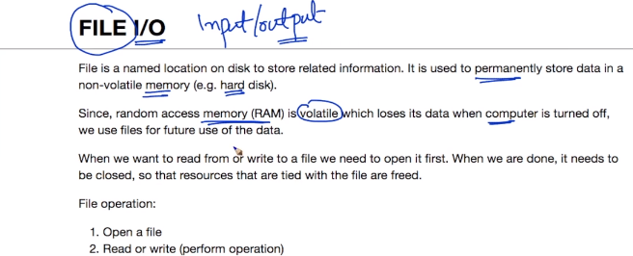

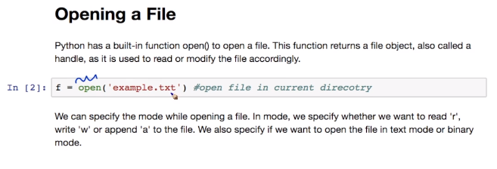

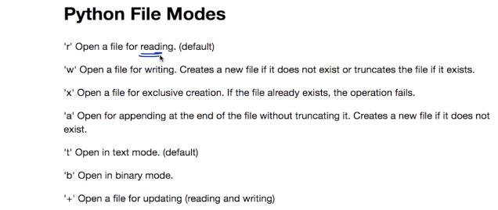

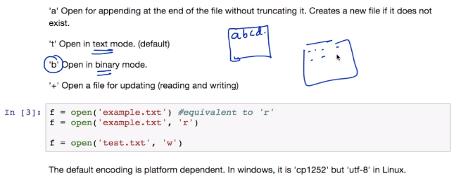

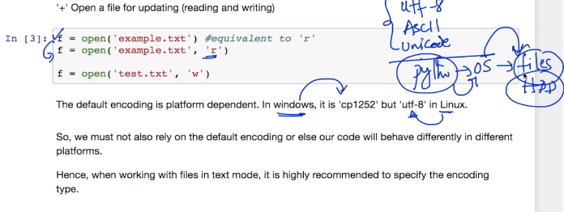

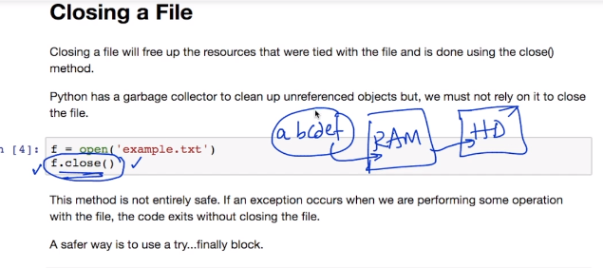

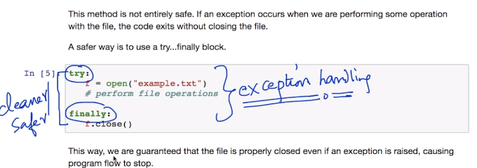

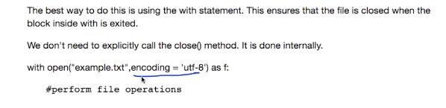

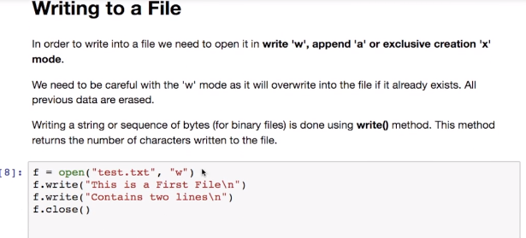

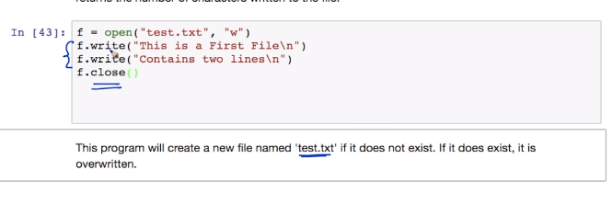

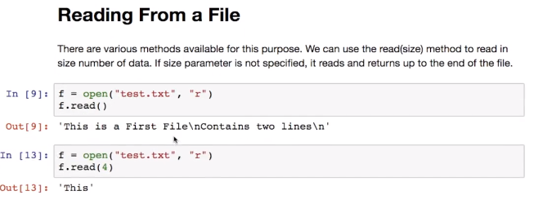



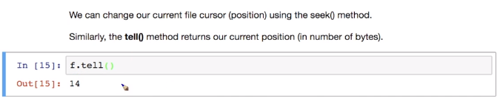

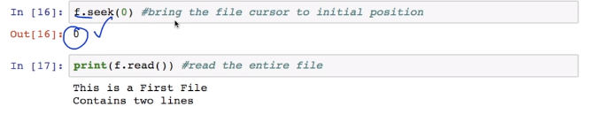

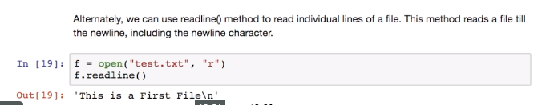

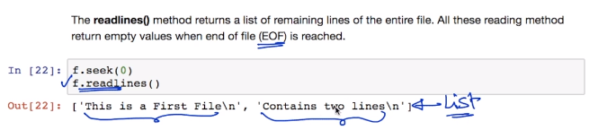

### Renaming and Deleting

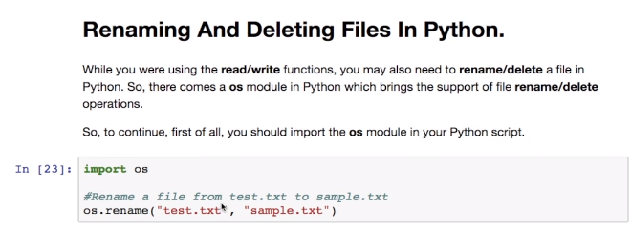

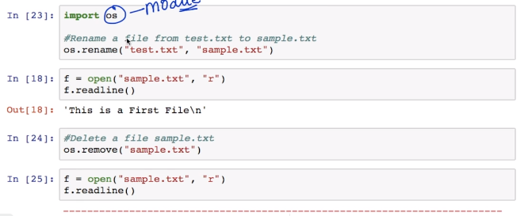

### Directory and File Management

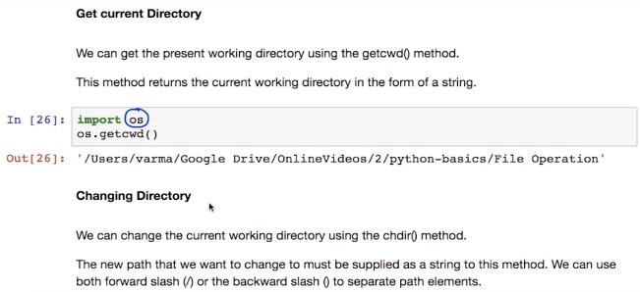

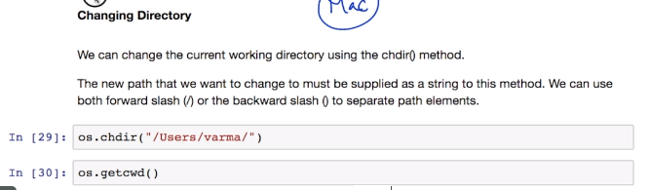

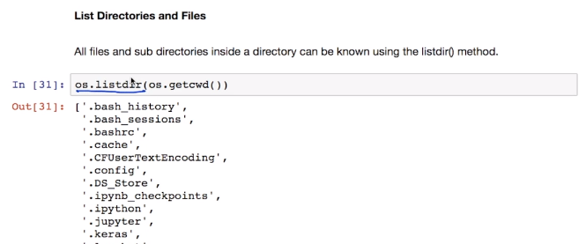

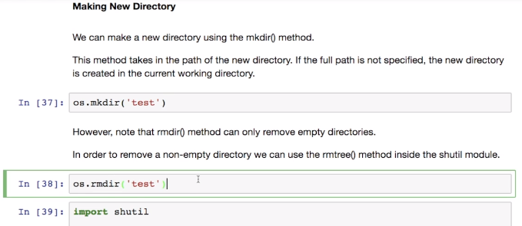

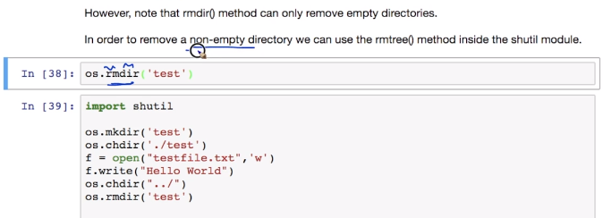

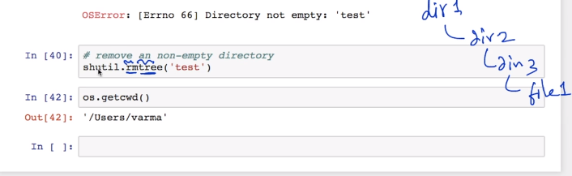

### Python Errors and Build-in-Exceptions

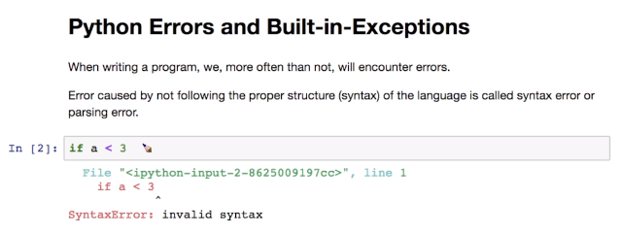

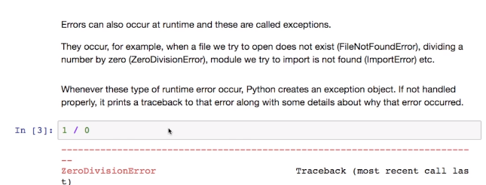

### Buil-in-Exceptions

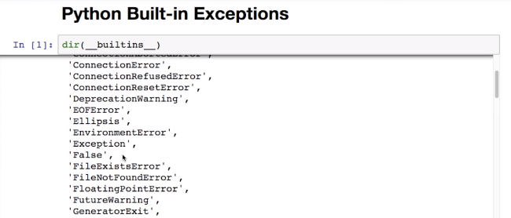

### Try, Except and Finally

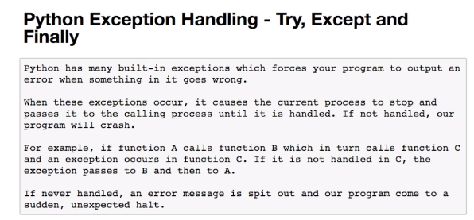

### Catching Exception

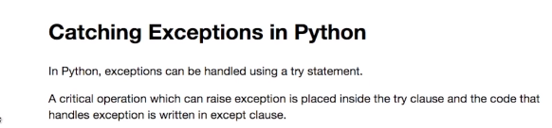

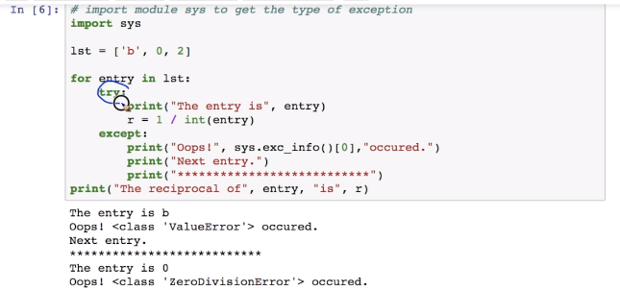

### Catching Specific Exceptions

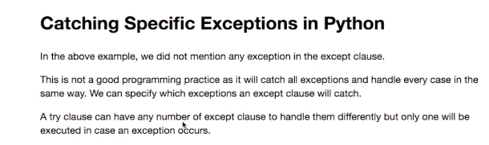

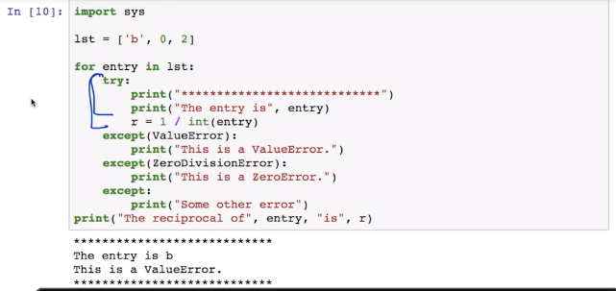

### Raisisng Exception

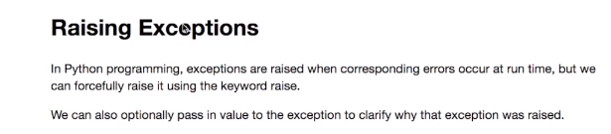

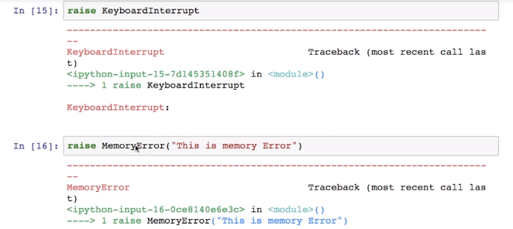

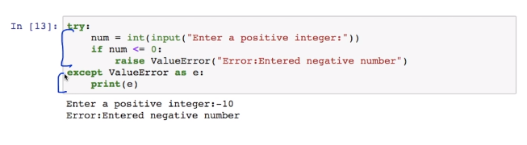

### Try … finally

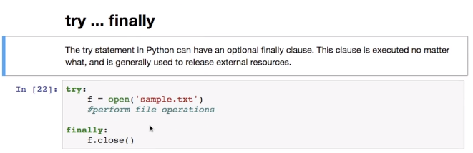

### Debugging

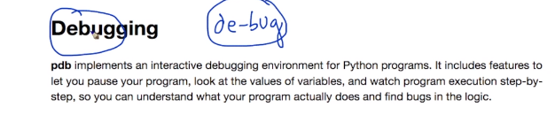

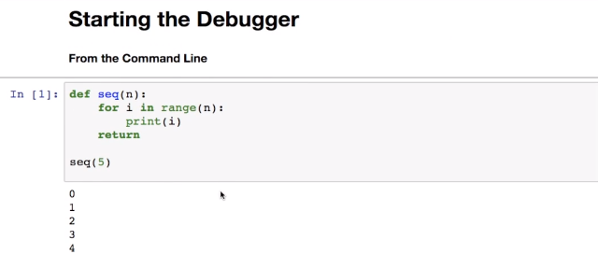

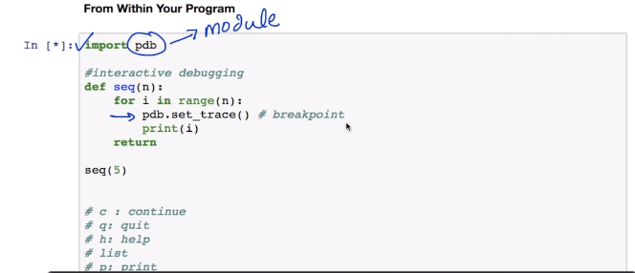

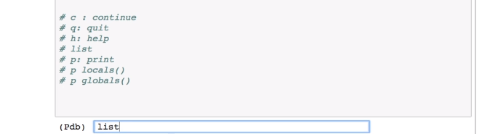

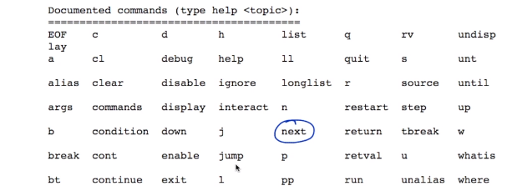

**Assignment 1** Practice Questions On Functions**:**

1. Write a function that inputs a number and prints the multiplication table of that number
2. Write a program to print twin primes less than 1000. If two consecutive odd numbers are both prime then they are known as twin primes
3. Write a program to find out the prime factors of a number. Example: prime factors of 56 -2, 2, 2, 7
4. Write a program to implement these formulae of permutations and combinations.Number of permutations of n objects taken r at a time: p(n, r) = n! / (n-r)!. Number of combinations of n objects taken r at a time is: c(n, r) = n! / (r!*(n-r)!) = p(n,r) / r!
5. Write a function that converts a decimal number to binary number
6. Write a function cubesum() that accepts an integer and returns the sum of the cubes of individual digits of that number. Use this function to make functions PrintArmstrong() and isArmstrong() to print Armstrong numbers and to find whether is an Armstrong number.
7. Write a function prodDigits() that inputs a number and returns the product of digits of that number.
8. If all digits of a number n are multiplied by each other repeating with the product, the one digit number obtained at last is called the multiplicative digital root of n. The number of times digits need to be multiplied to reach one digit is called the multiplicative persistance of n. Example: 86 -> 48 -> 32 -> 6 (MDR 6, MPersistence 3) 341 -> 12->2 (MDR 2, MPersistence 2) Using the function prodDigits() of previous exercise write functions MDR() and MPersistence() that input a number and return its multiplicative digital root and multiplicative persistence respectively
9. Write a function sumPdivisors() that finds the sum of proper divisors of a number. Proper divisors of a number are those numbers by which the number is divisible, except the number itself. For example proper divisors of 36 are 1, 2, 3, 4, 6, 9, 18
10. A number is called perfect if the sum of proper divisors of that number is equal to the number. For example 28 is perfect number, since 1+2+4+7+14=28. Write a program to print all the perfect numbers in a given range
11. Two different numbers are called amicable numbers if the sum of the proper divisors of each is equal to the other number. For example 220 and 284 are amicable numbers. Sum of proper divisors of 220 = 1+2+4+5+10+11+20+22+44+55+110 = 284 Sum of proper divisors of 284 = 1+2+4+71+142 = 220 Write a function to print pairs of amicable numbers in a range
12. Write a program which can filter odd numbers in a list by using filter function
13. Write a program which can map() to make a list whose elements are cube of elements in a given list
14. Write a program which can map() and filter() to make a list whose elements are cube of even number in a given list

## NumPy (<https://stackoverflow.com/questions/8385602/why-are-numpy-arrays-so-fast>)

### Introduction

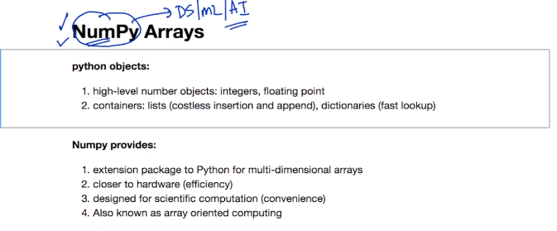

### Simple Array

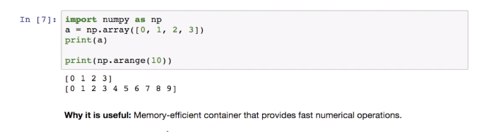

### Why is it useful

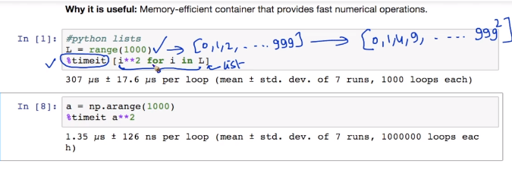

### Create Array

### 1-D array

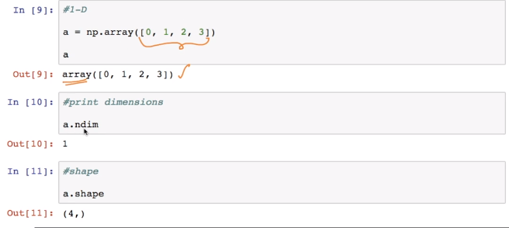

2-D array

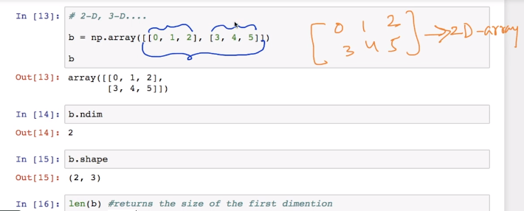

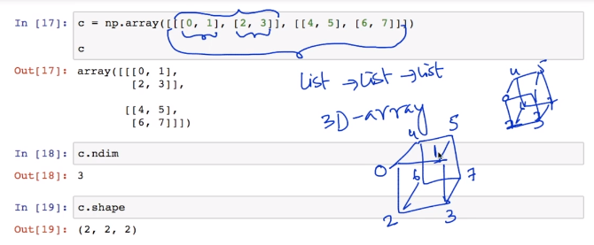

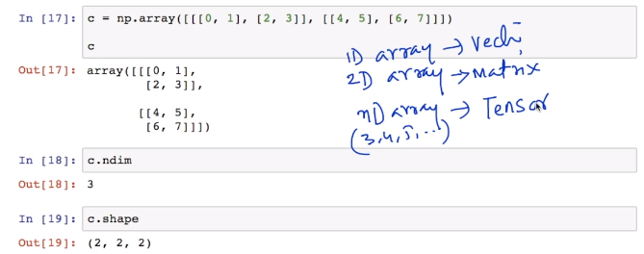

Arrange

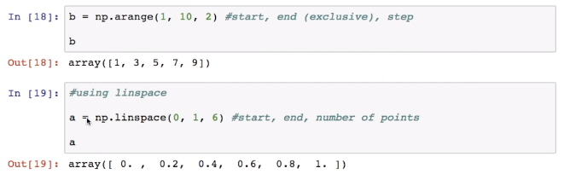

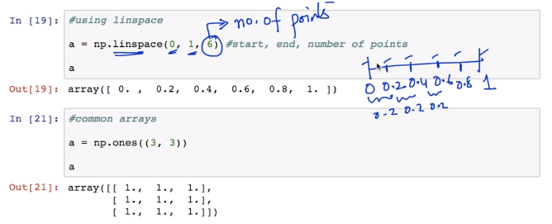

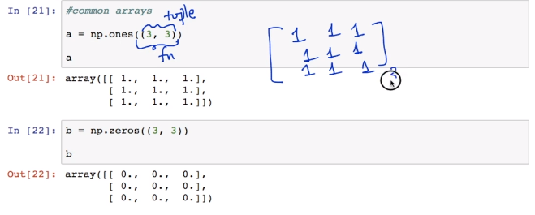

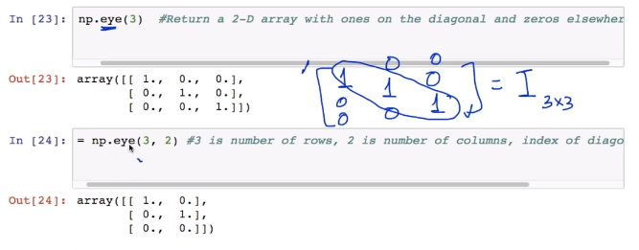

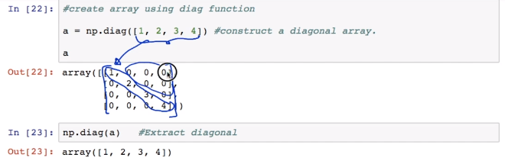

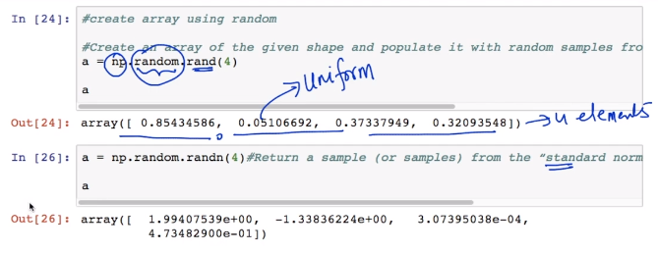

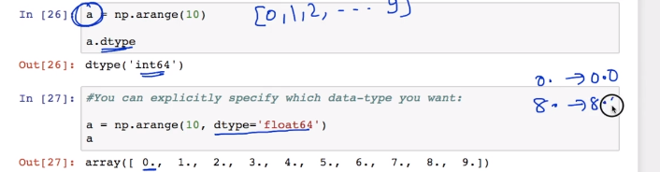

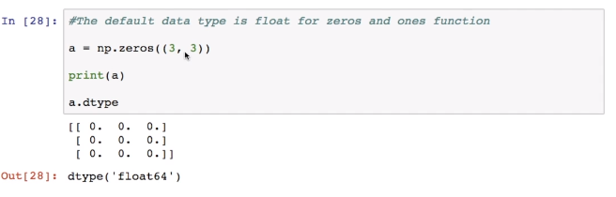

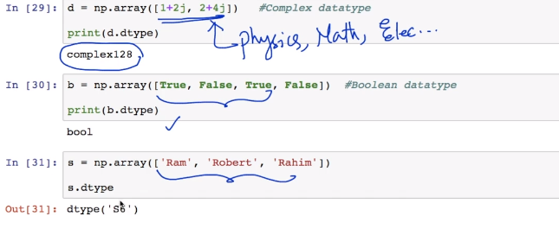

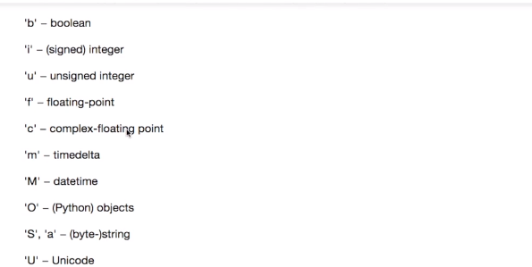

### 

### Indexing and Slicing

#### Indexing

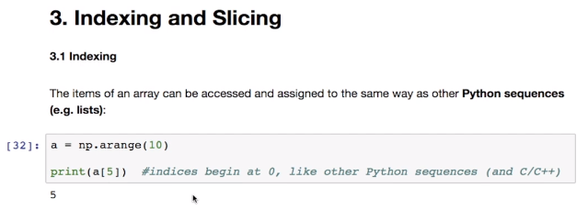

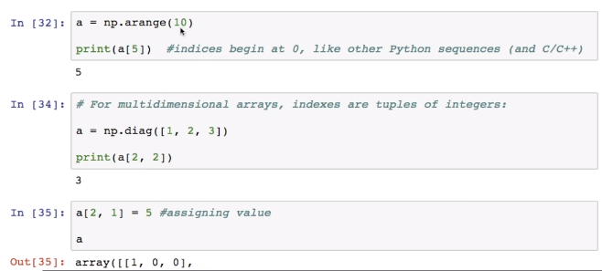

#### Slicing

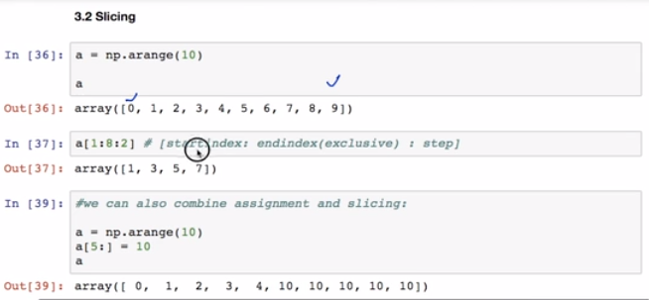

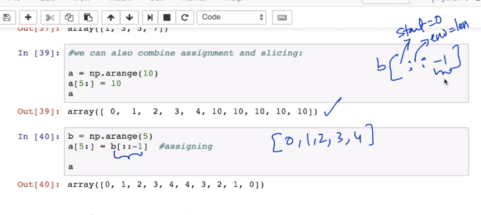

### Copies and Views

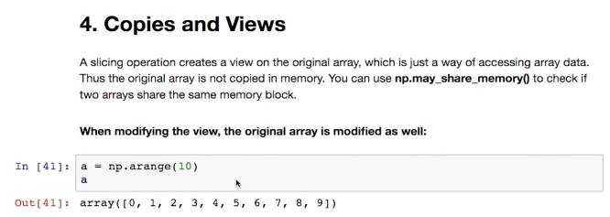

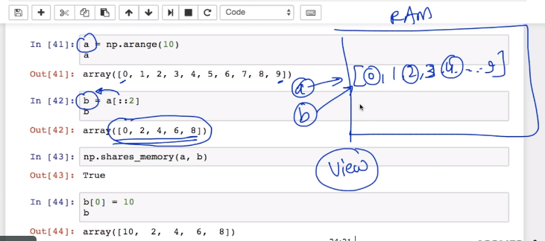

#### Shared Memory Issue



#### Workaround for it

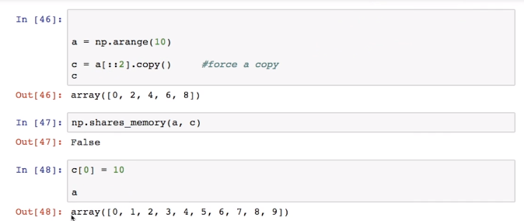

### Fancy Indexing

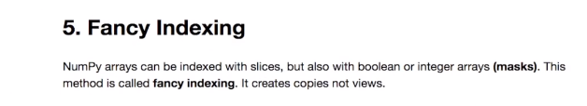

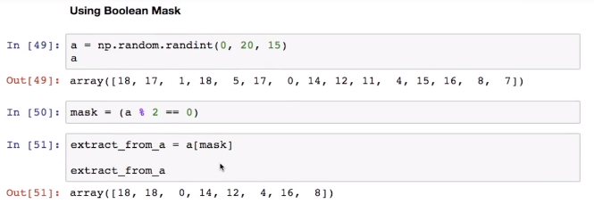

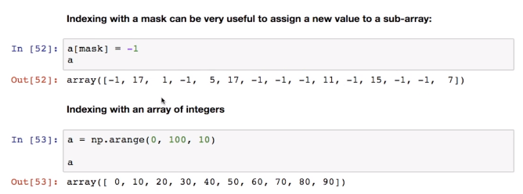

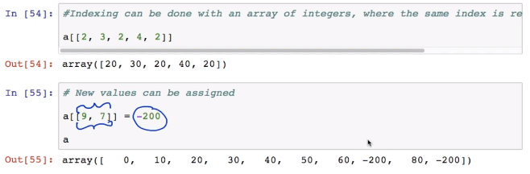

### Elementwise Operations

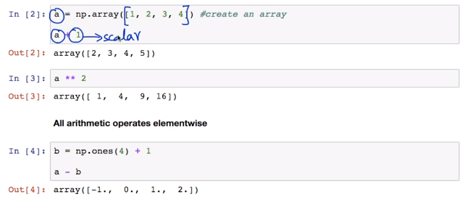

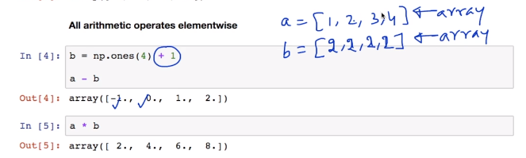

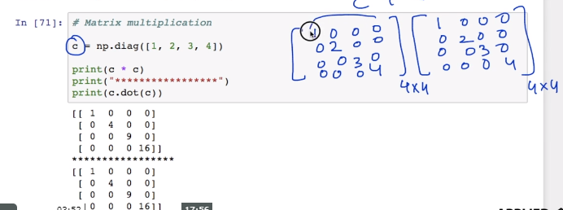

Comparison

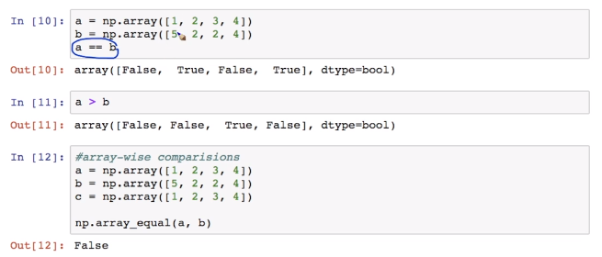

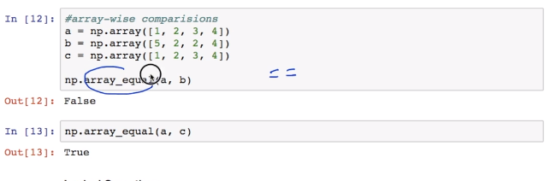

#### Logical Operations

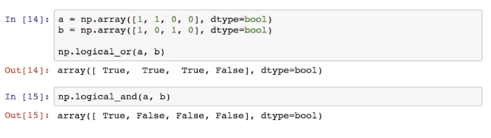

#### Transcendental Functions

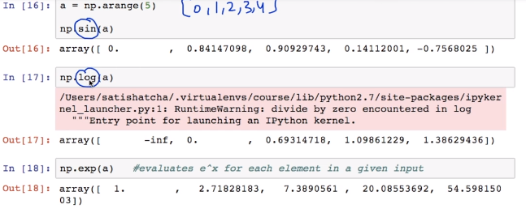

#### Shape Mismatch

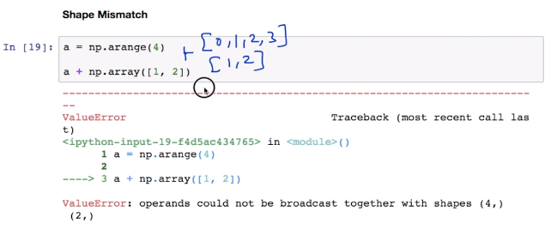

#### Basic Reductions

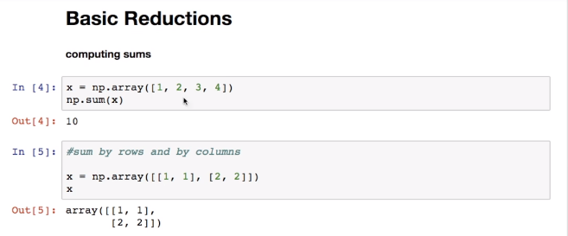

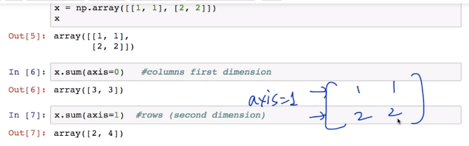

#### Other Reductions

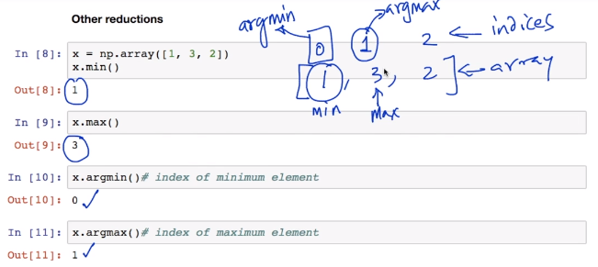

#### Logical Operations

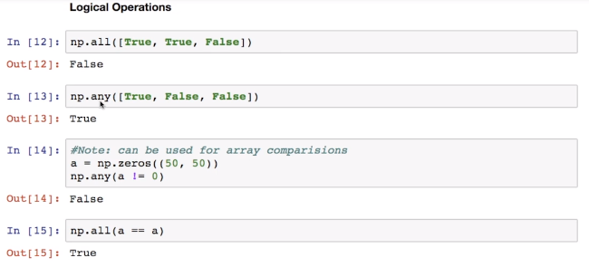

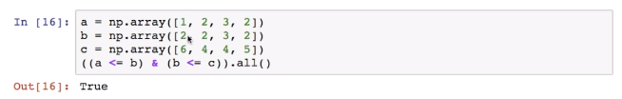

#### Statistics

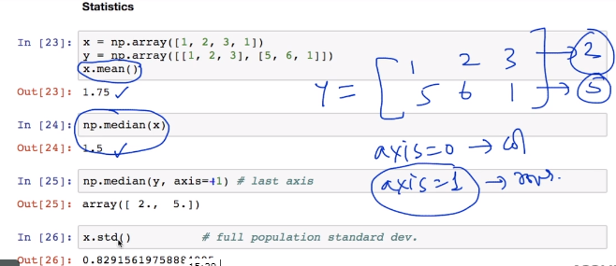

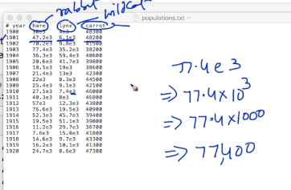

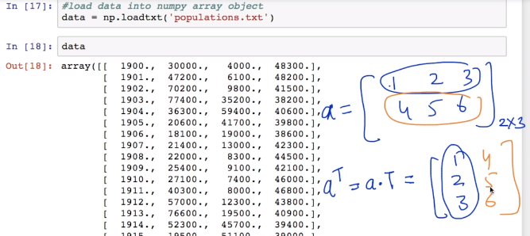

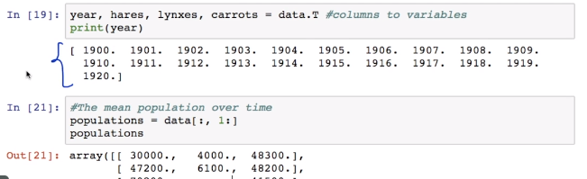

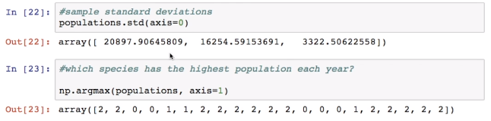

### Broadcasting

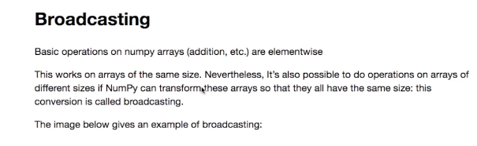

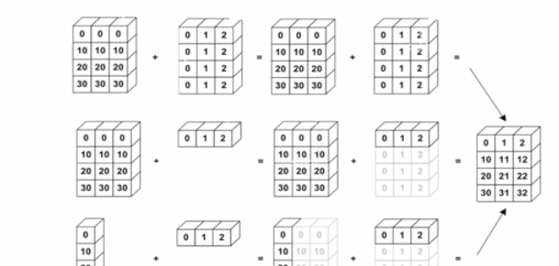

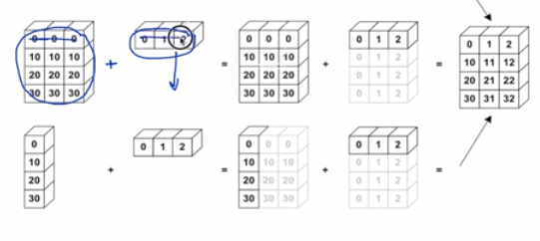

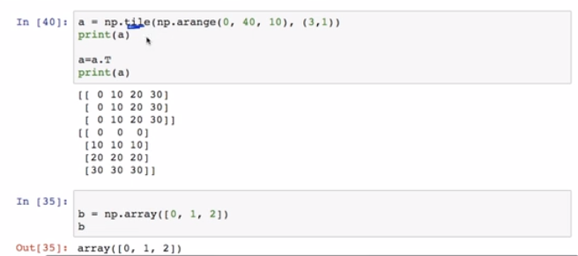

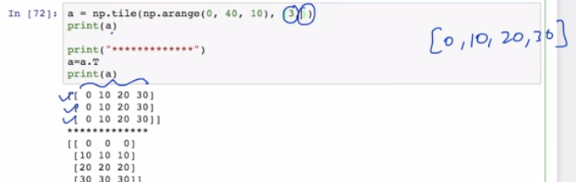

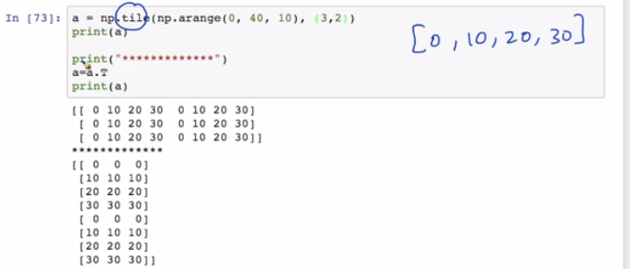

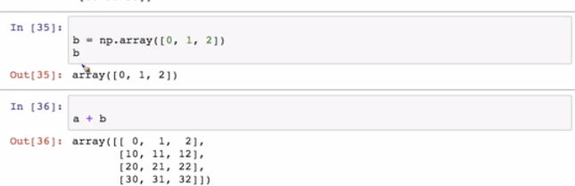

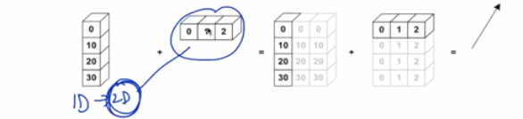

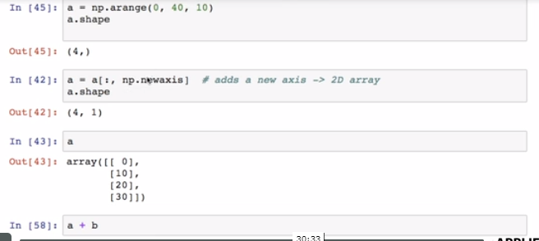

### Array Manipulations

#### Flattening

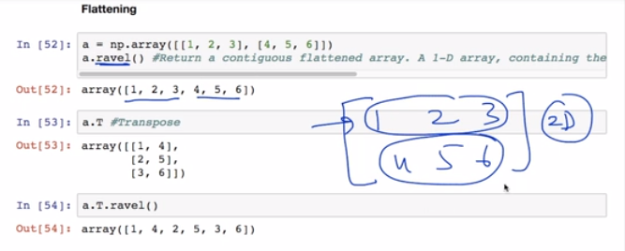

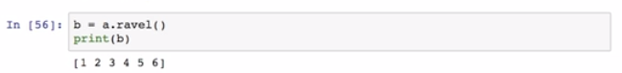

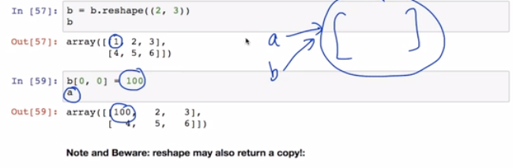

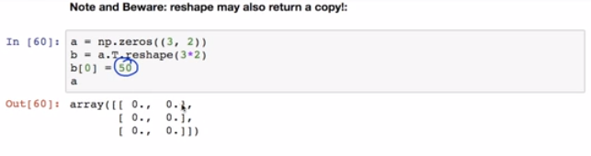

### Adding a Dimension

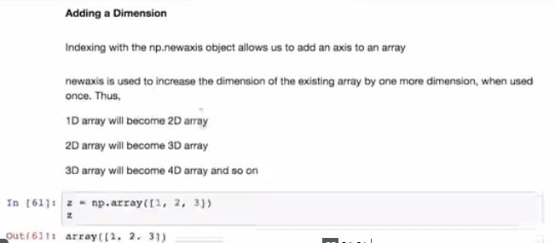

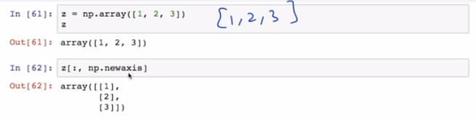

### Dimension Shufflin

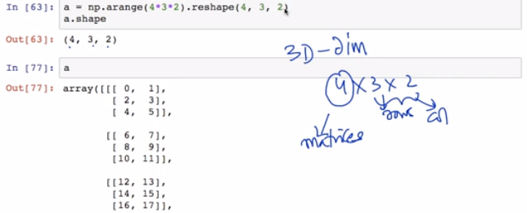

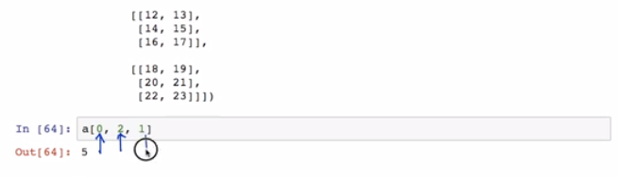

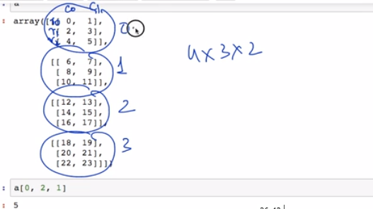

### Resizing

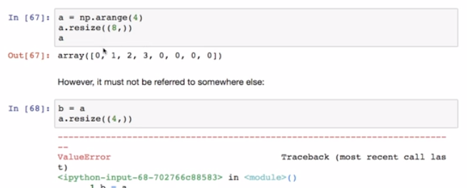

#### Sorting Data

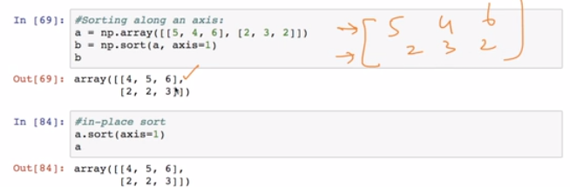

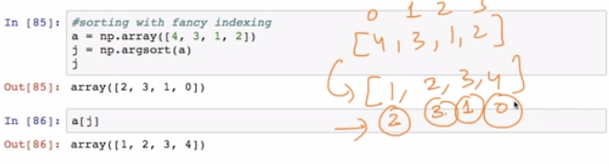

## 

## Matplotlib

### What is Pyplot?

### Simple Plot?

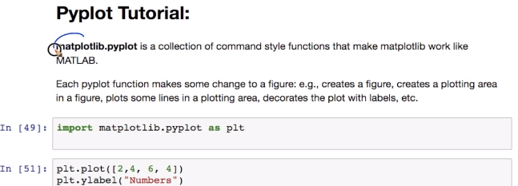

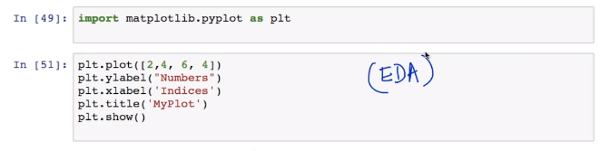

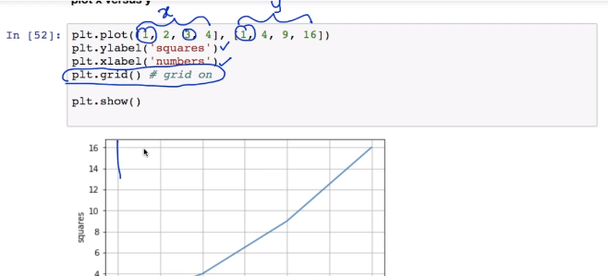

### Grid and Plot Properties

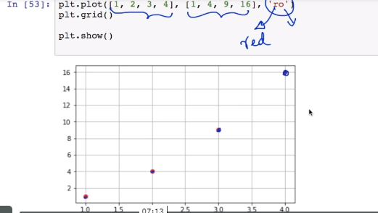

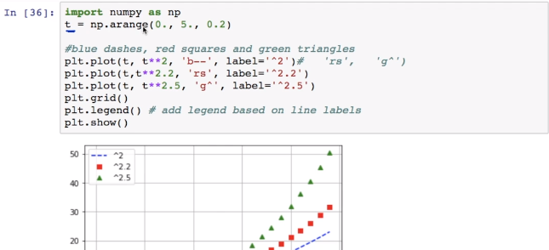

### Controlling line properties

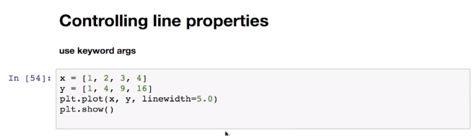

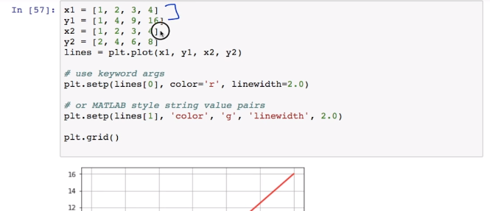

### Multiple plots

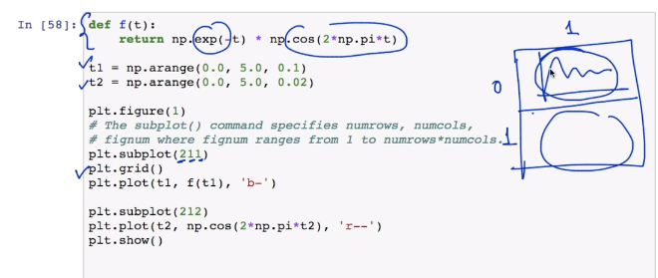

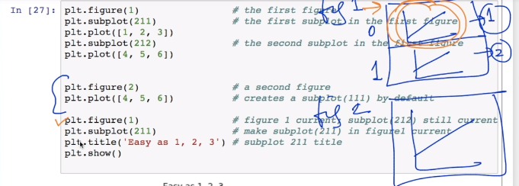

## Pandas

### Introduction

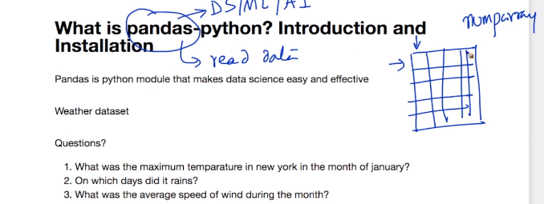

### Example

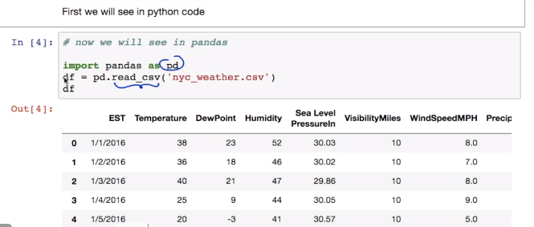

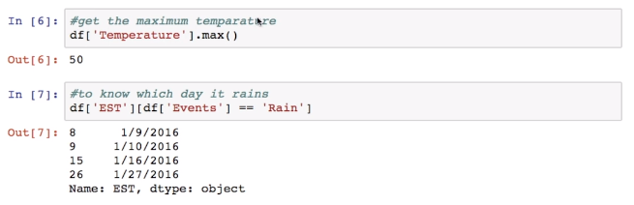

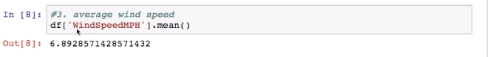

### Introduction to Pandas Data Frames

#### Creating dataframe

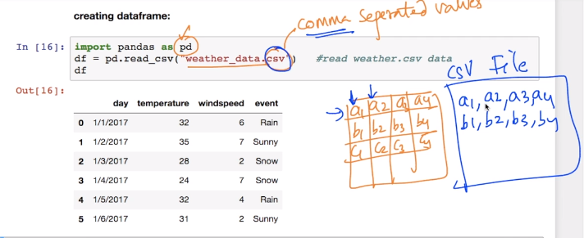

#### Using list of tuples

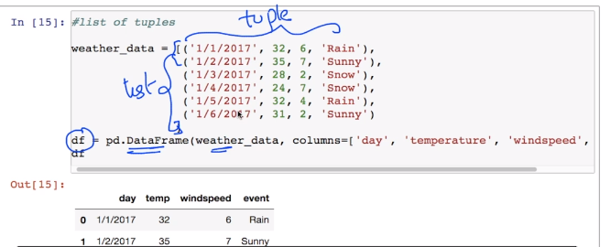

#### DataFrame Function : shape, head(), tail(), slicing(), single column, multiple column, describe()

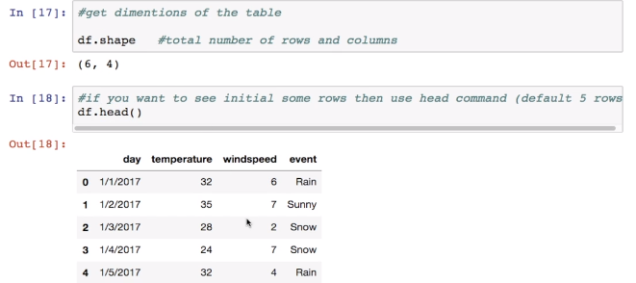

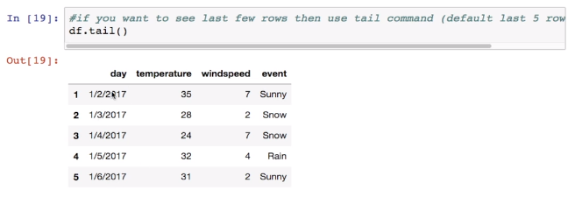

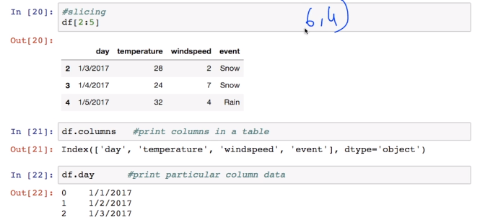

Select Single Column

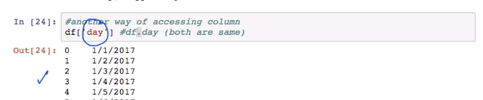

Select Multiple Column

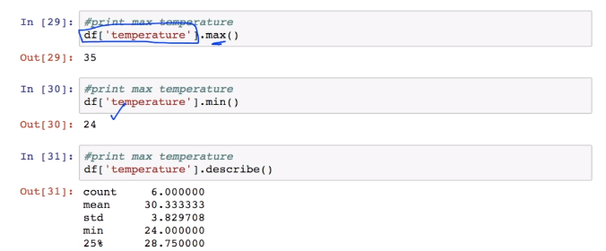

Describe

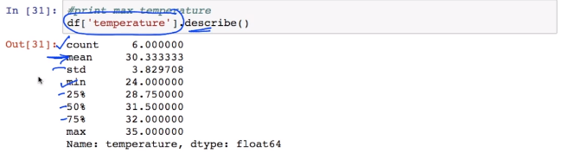

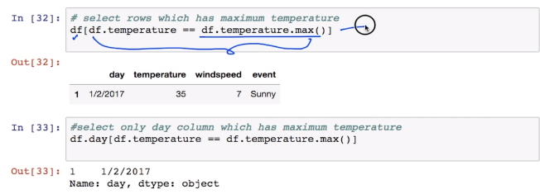

### Key Operations

Read and Write CSV and XLS Files

#### Load CSV File

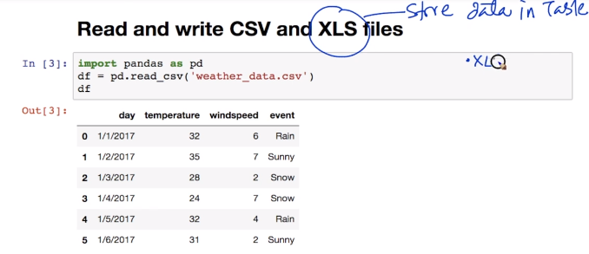

#### Load Excel

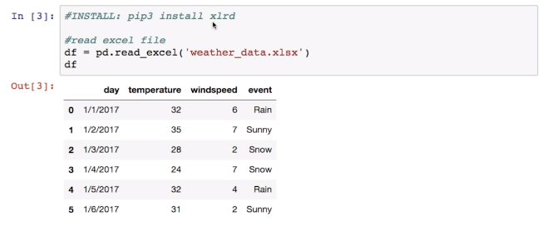

#### Write Data to CSV and XLS

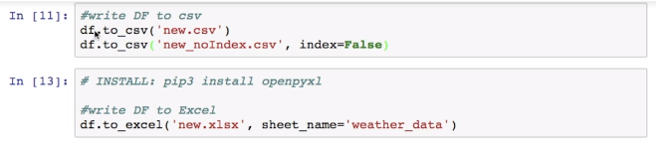

#### GROUP BY

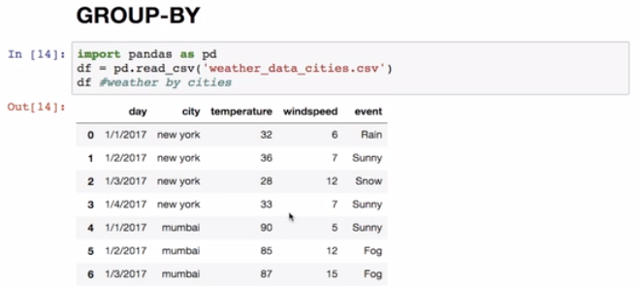

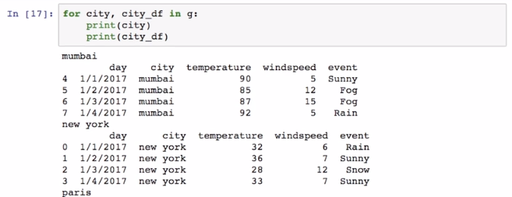

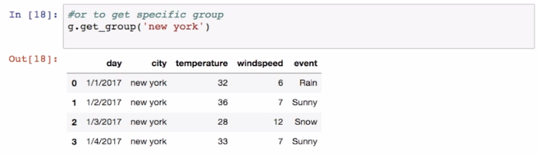

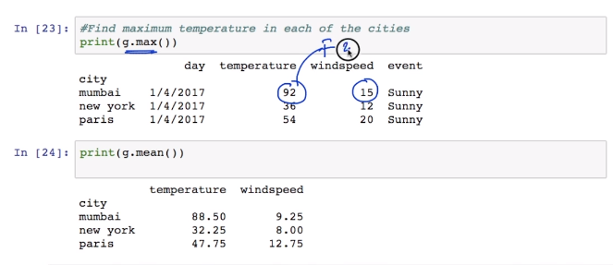

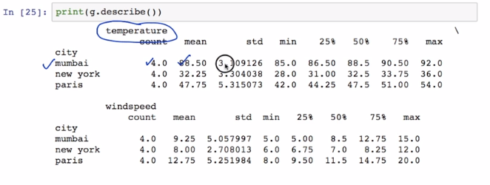

#### Concatenate Data Frames

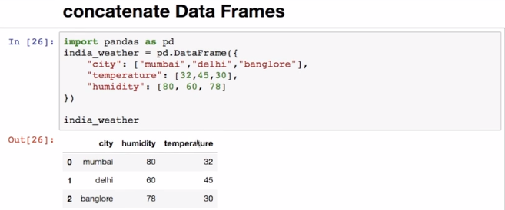

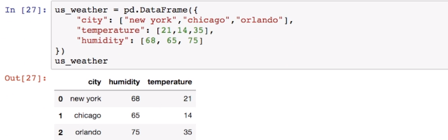

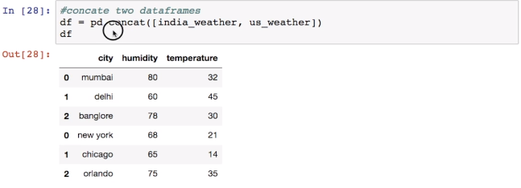

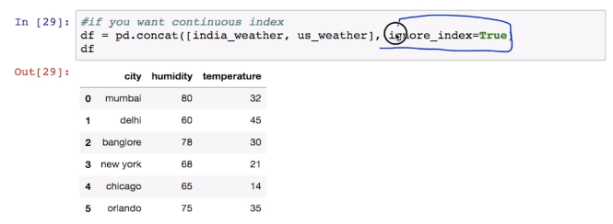

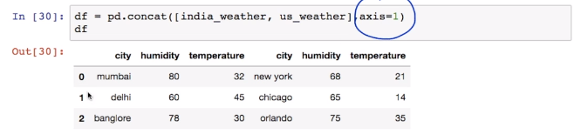

#### Join Data Frames

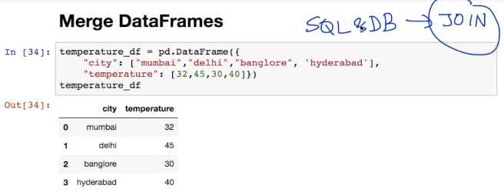

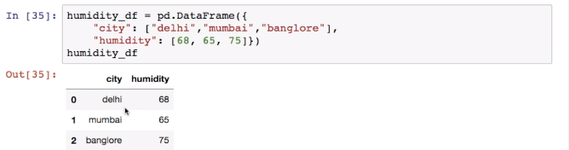

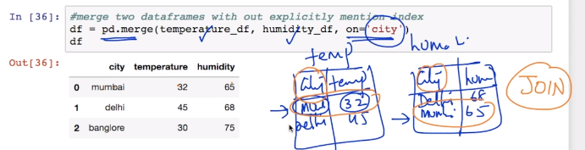

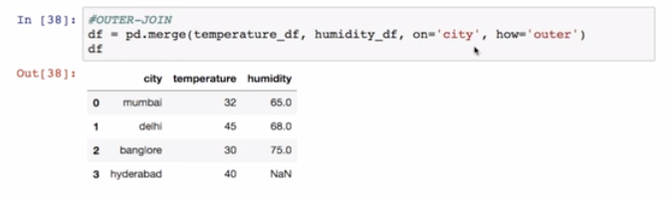

#### Numerical Indexing

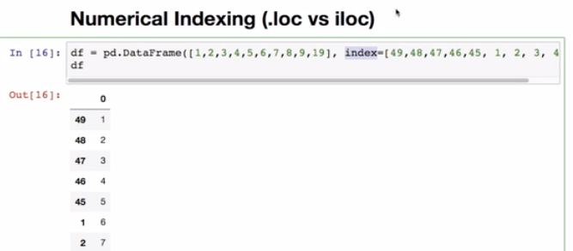

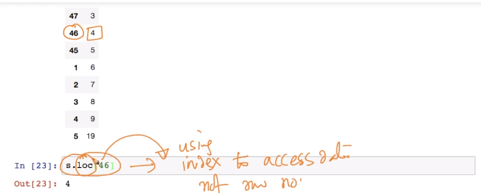

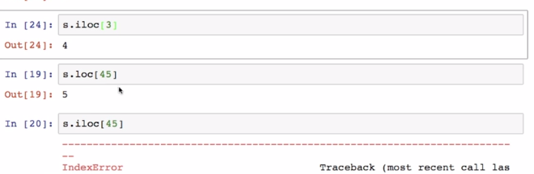

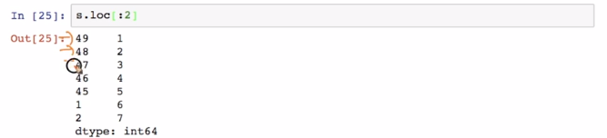

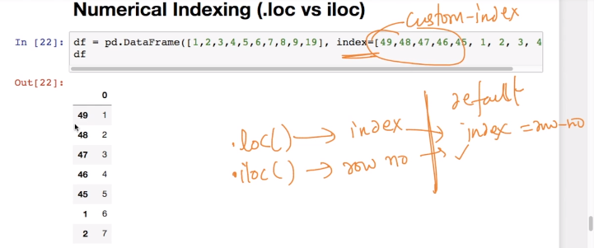

## Computational Complexity

### Space and Time Complexity

